Table of Contents
Parking Lot LLD Design 2
Component Diagram 2
Class Diagram 4
Approach 1: Vehicle Size Based Approach of Designing Parking Lot 5
Multi-Floor Parking Lot 10
Approach 2: Vehicle Capacity Based Approach of Designing Parking Lot 13
UML diagram of Capacity based Parking Lot 13
Two Vehicle at the same time handling (Locking Mechanism): 14
What is Pessimistic Locking 15
Optimistic Locking 16
Optimistic v/s Pessimistic 17
Optimistic Locking Code 18
Retry Mechanism for Optimistic Locking 20

Parking Lot LLD Design

Component Diagram
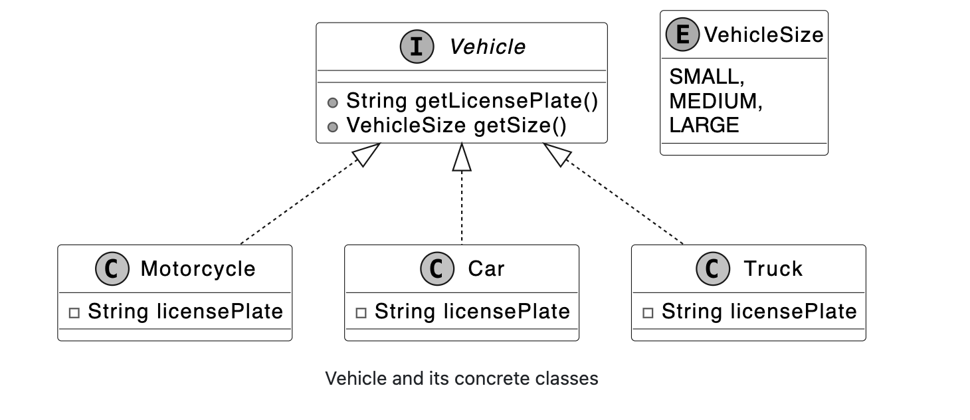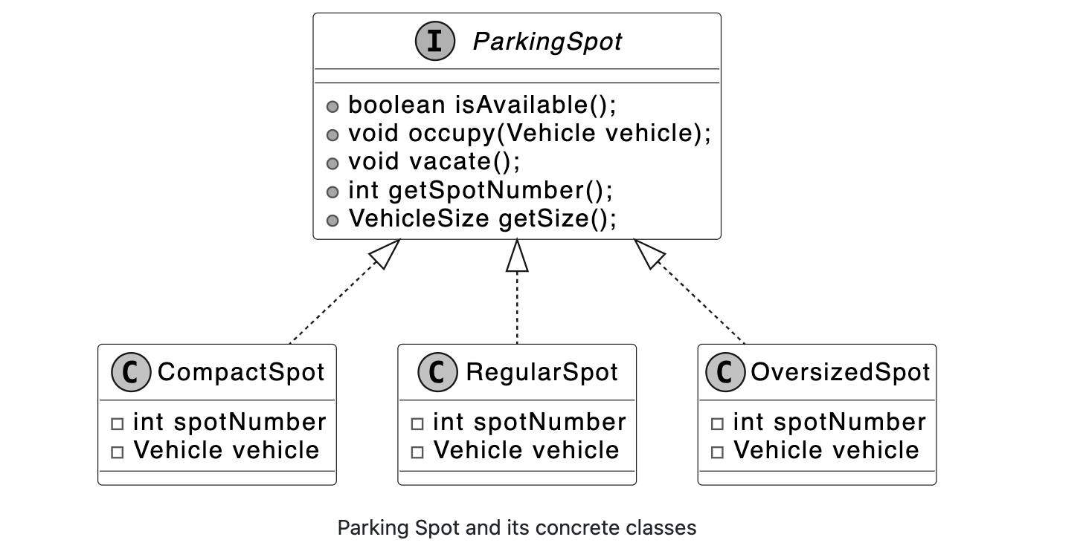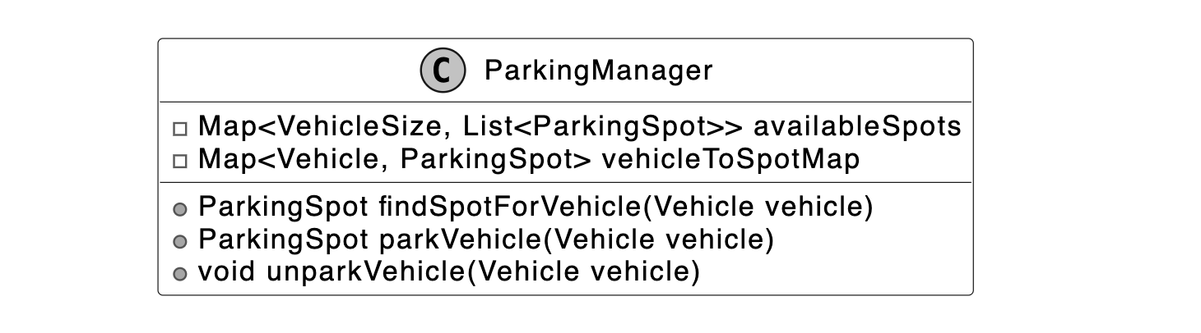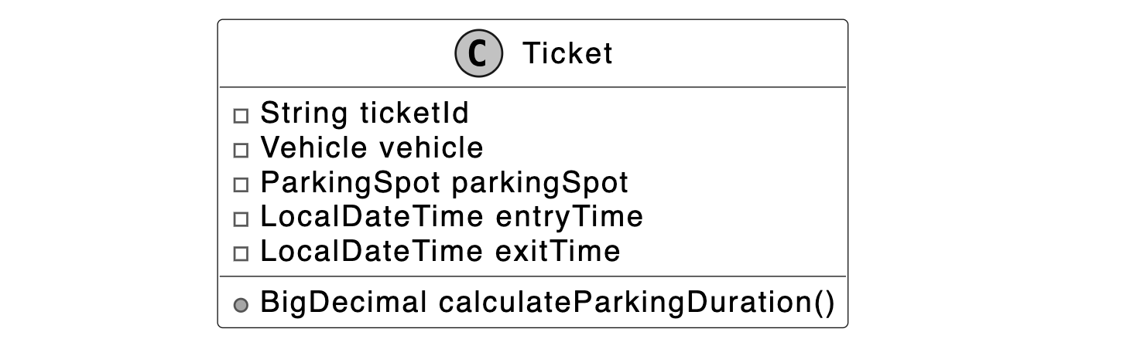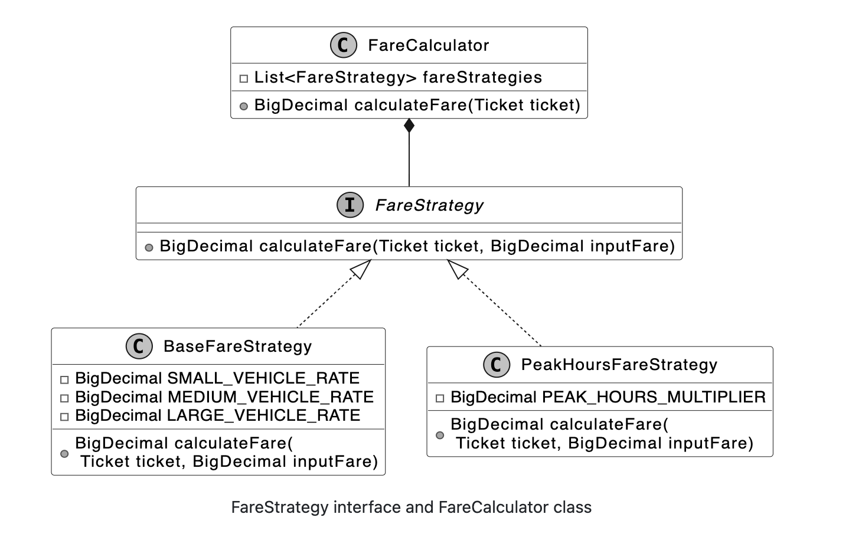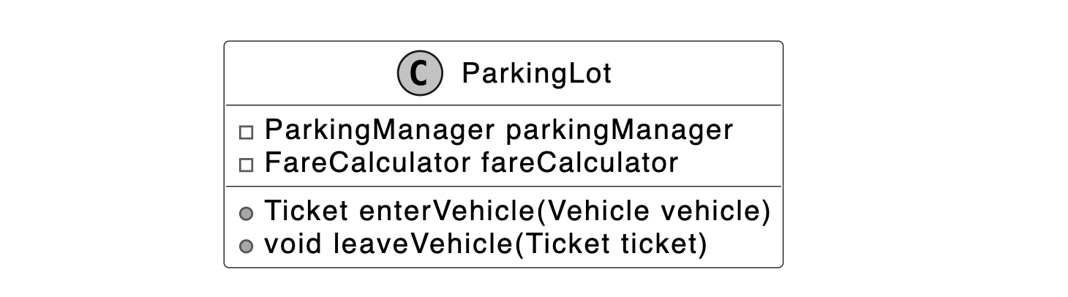

Class Diagram
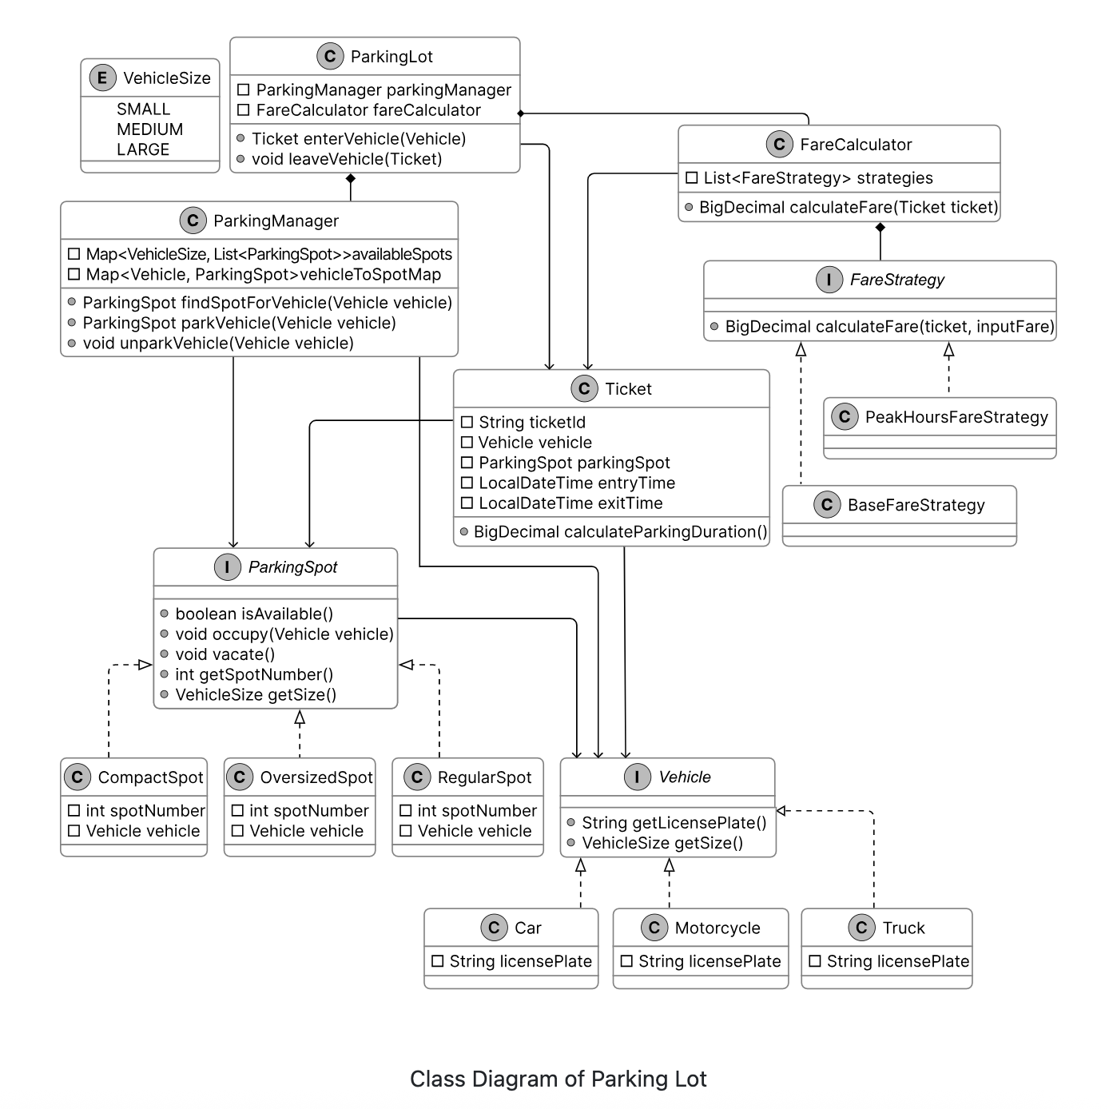

Approach 1: Vehicle Size Based Approach of Designing Parking Lot
I have changed a lot of things because I need to persist things in DB and I also need to learn the mappings so with the help of ChatGPT now this is what our final design looks like:
We have 3 entities as of now:
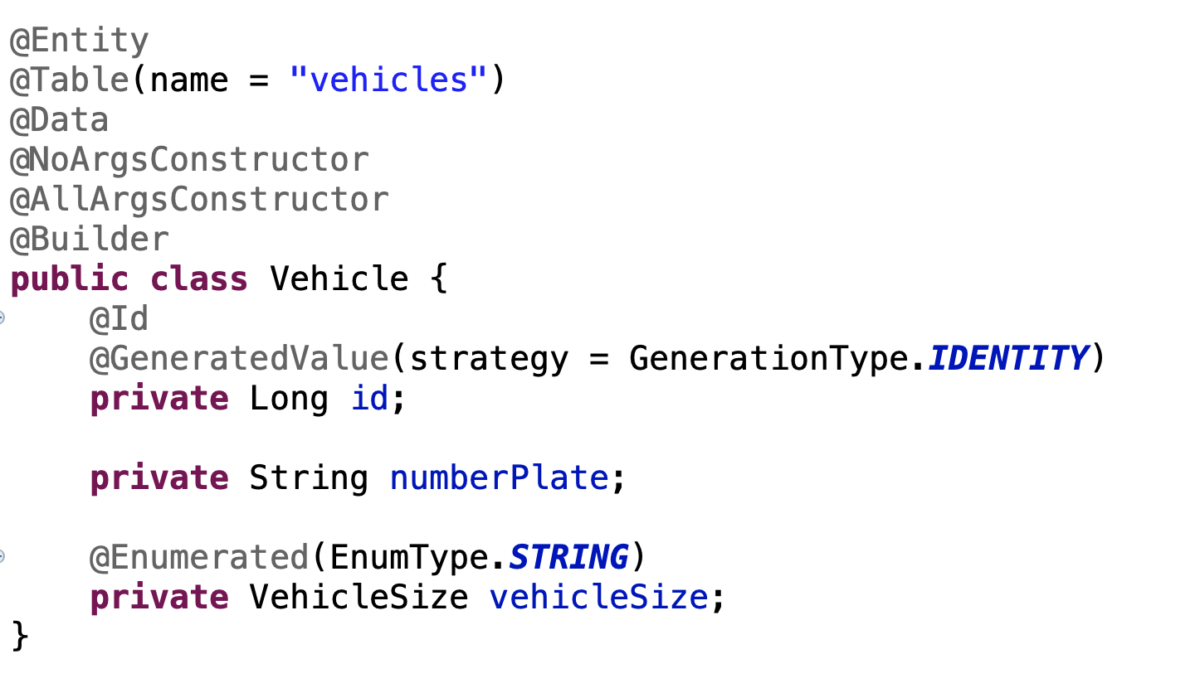

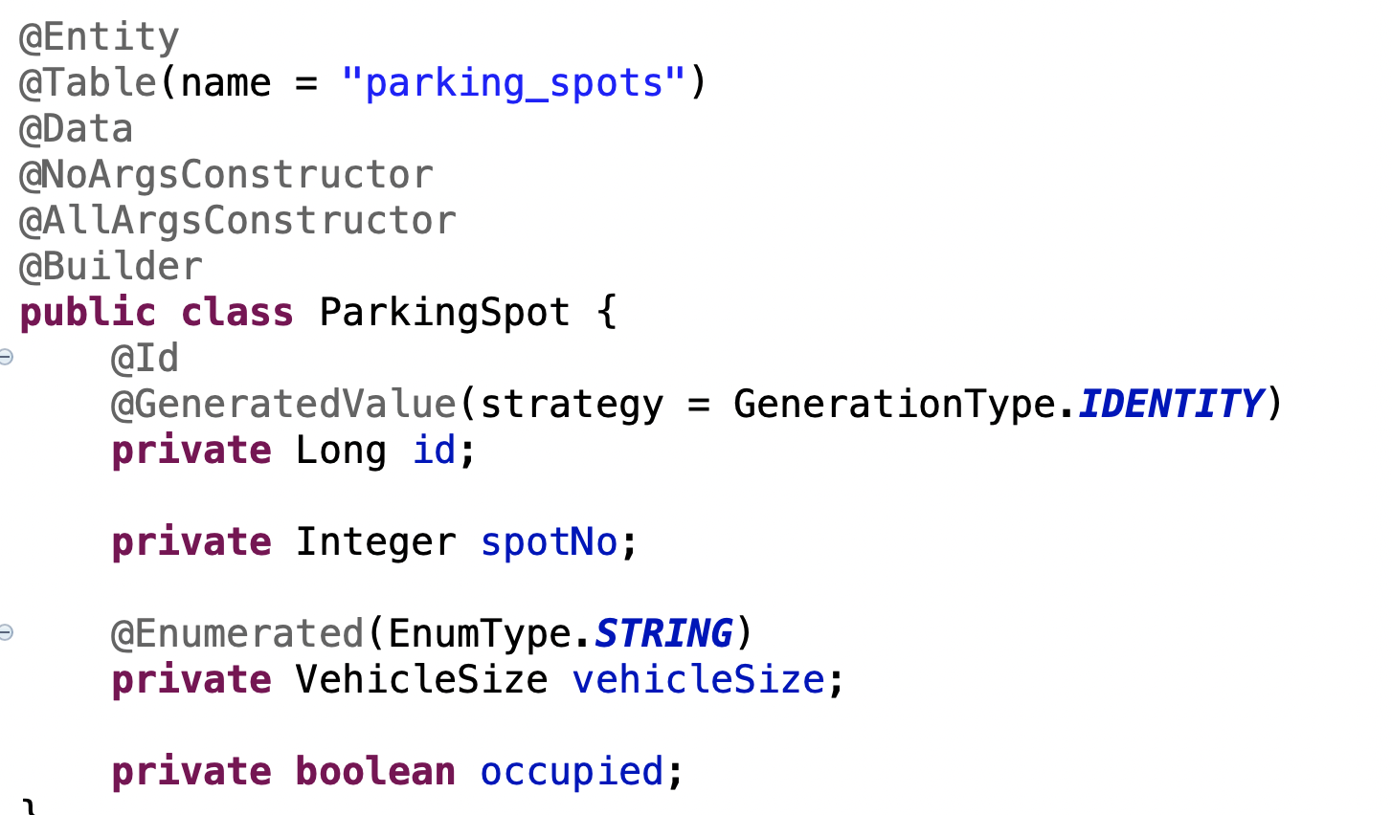

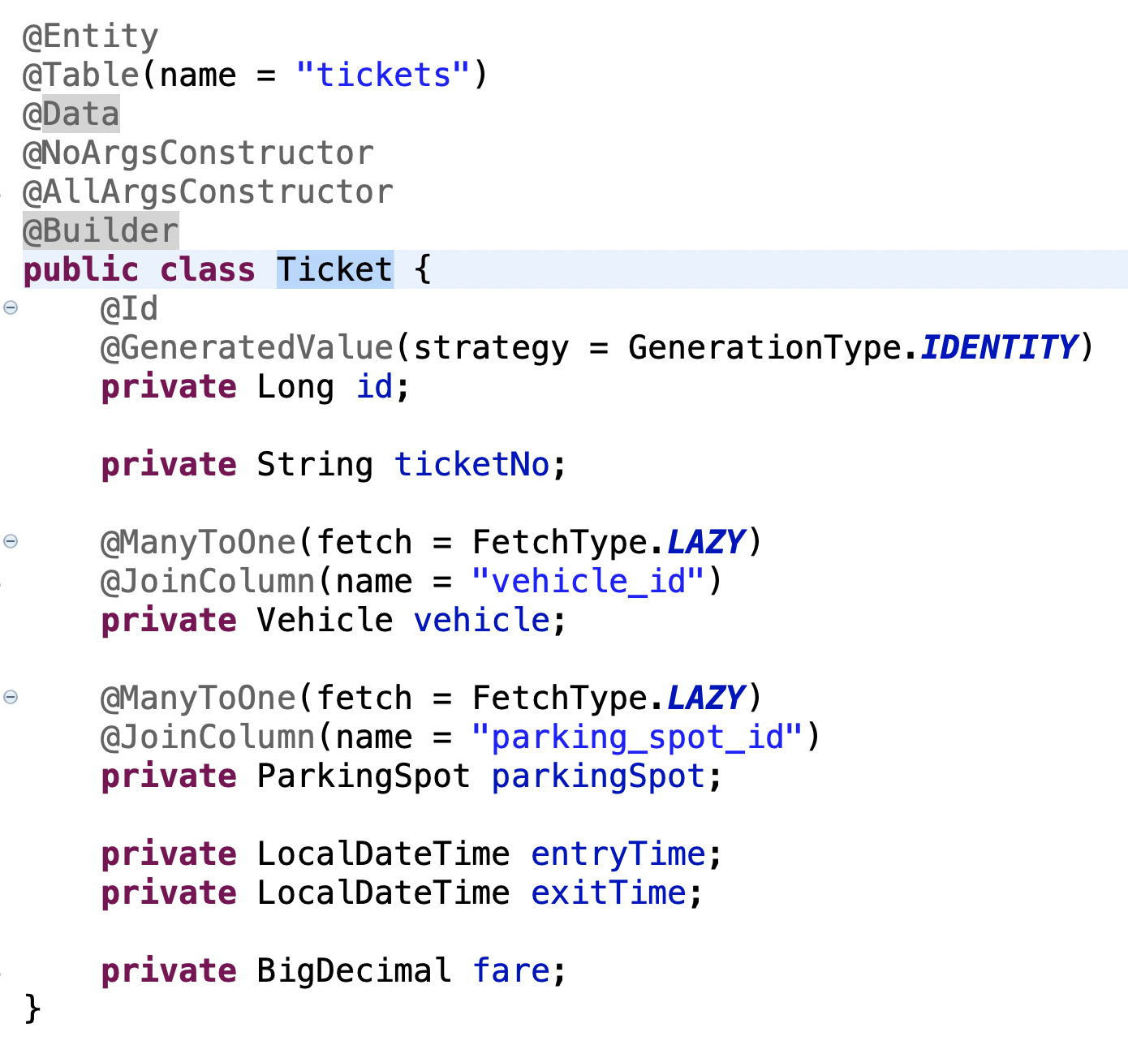

We have FareStrategy as well and
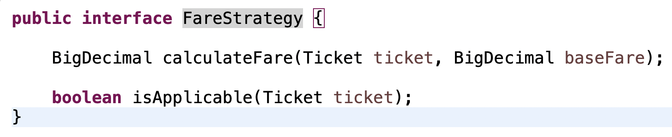
This @Order annotation is imp because we want to apply DefaultFareStrategy first and also we have an applicable method which tells this strategy is applicable or not.
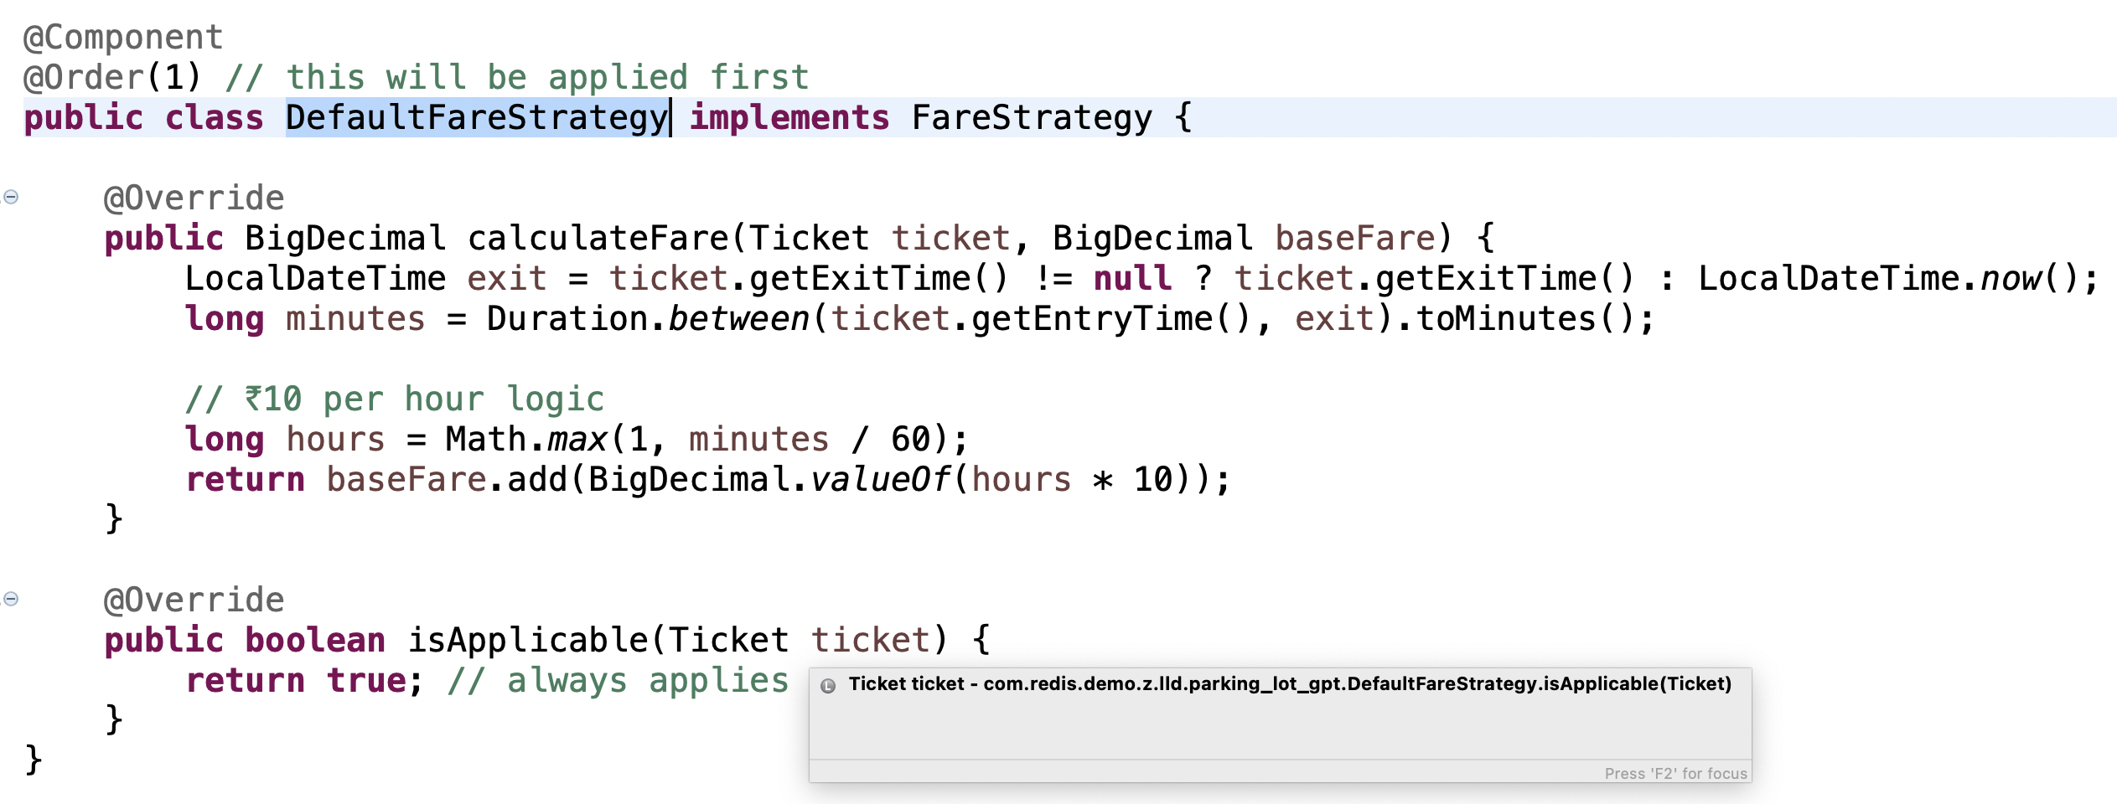

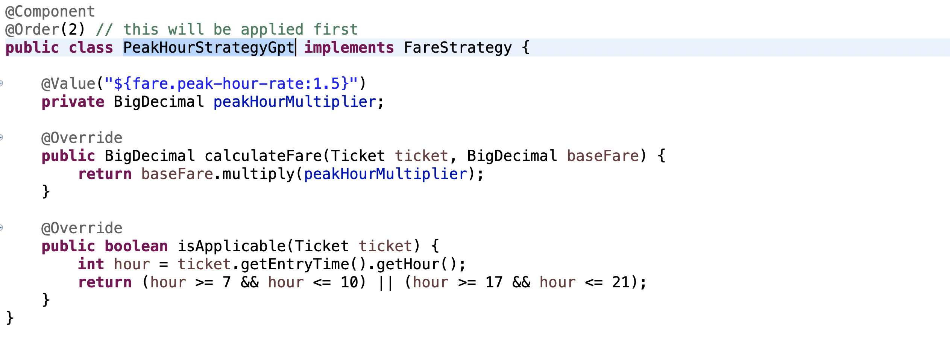

Controller will look like this
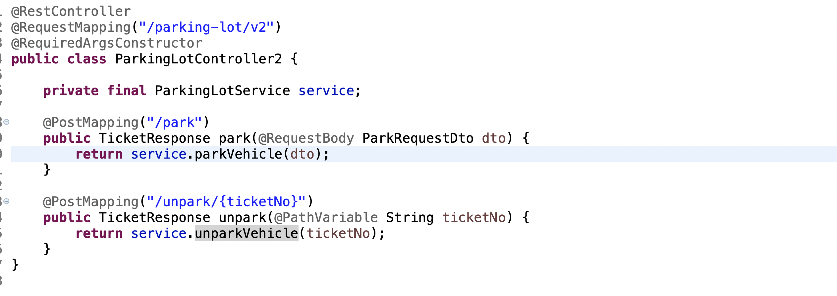

Service class will look like this
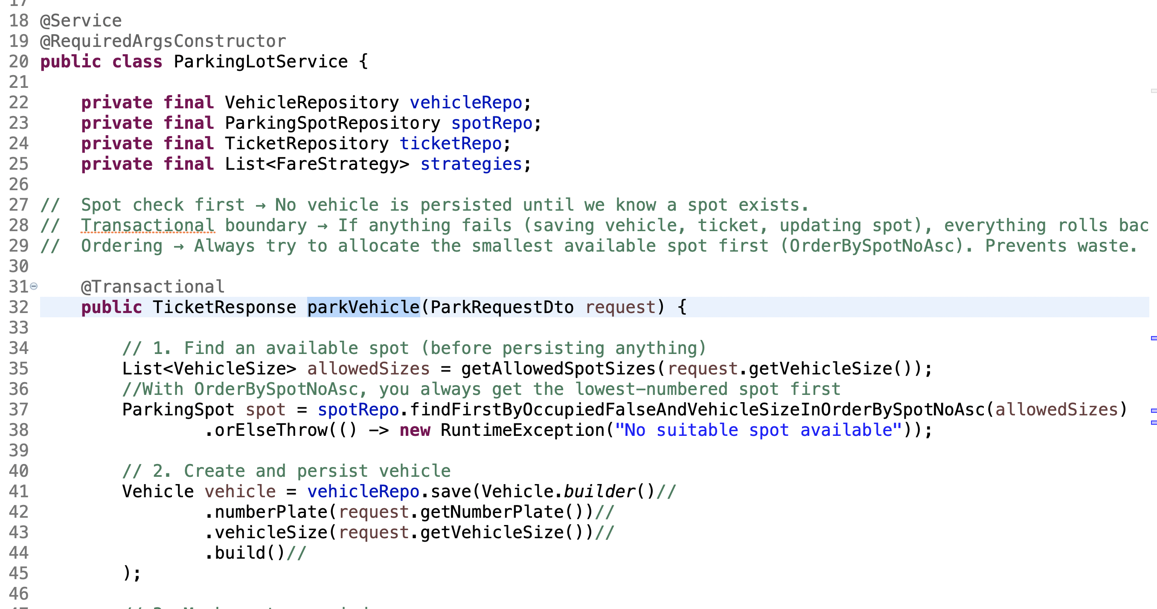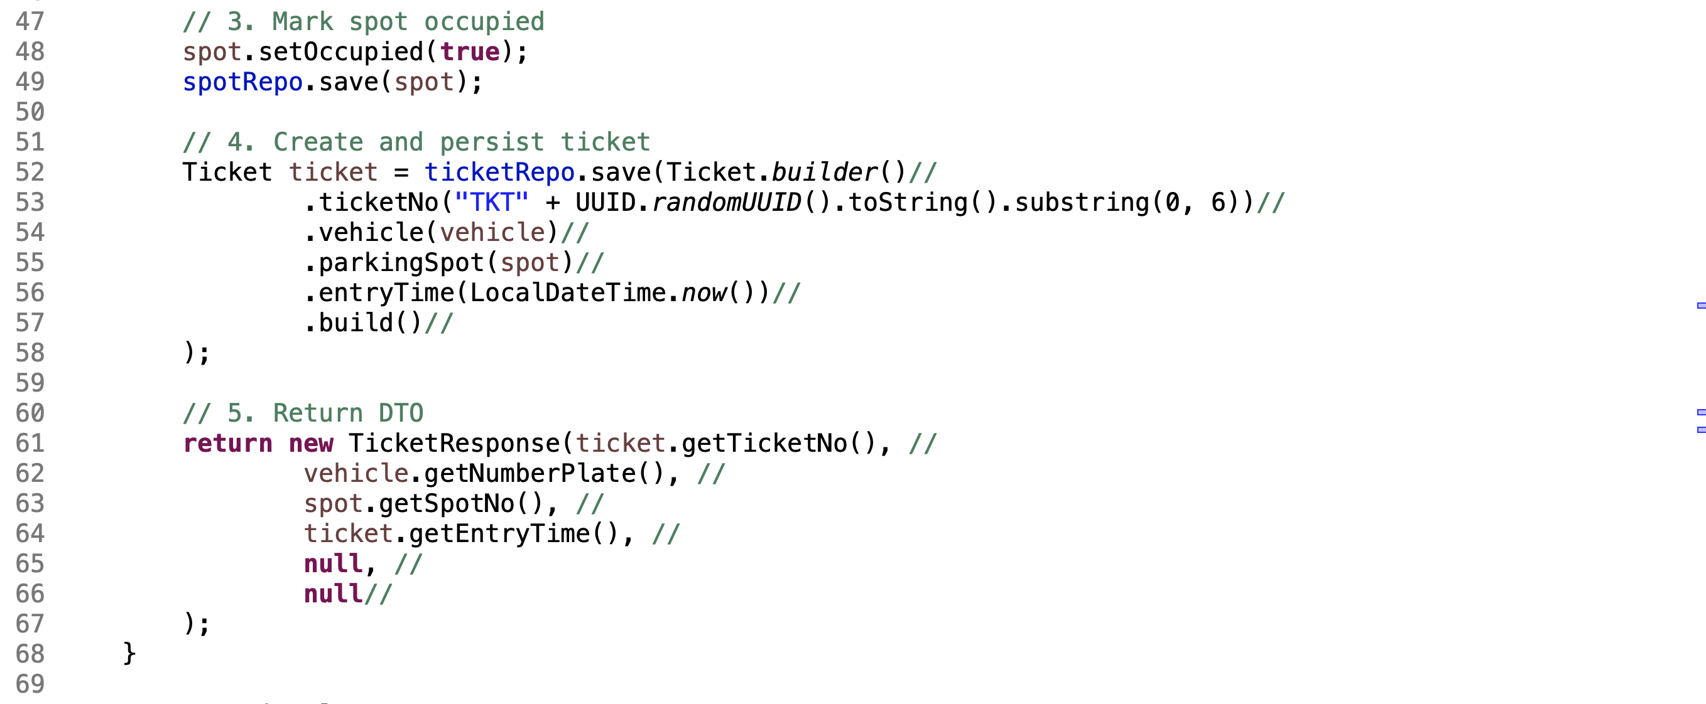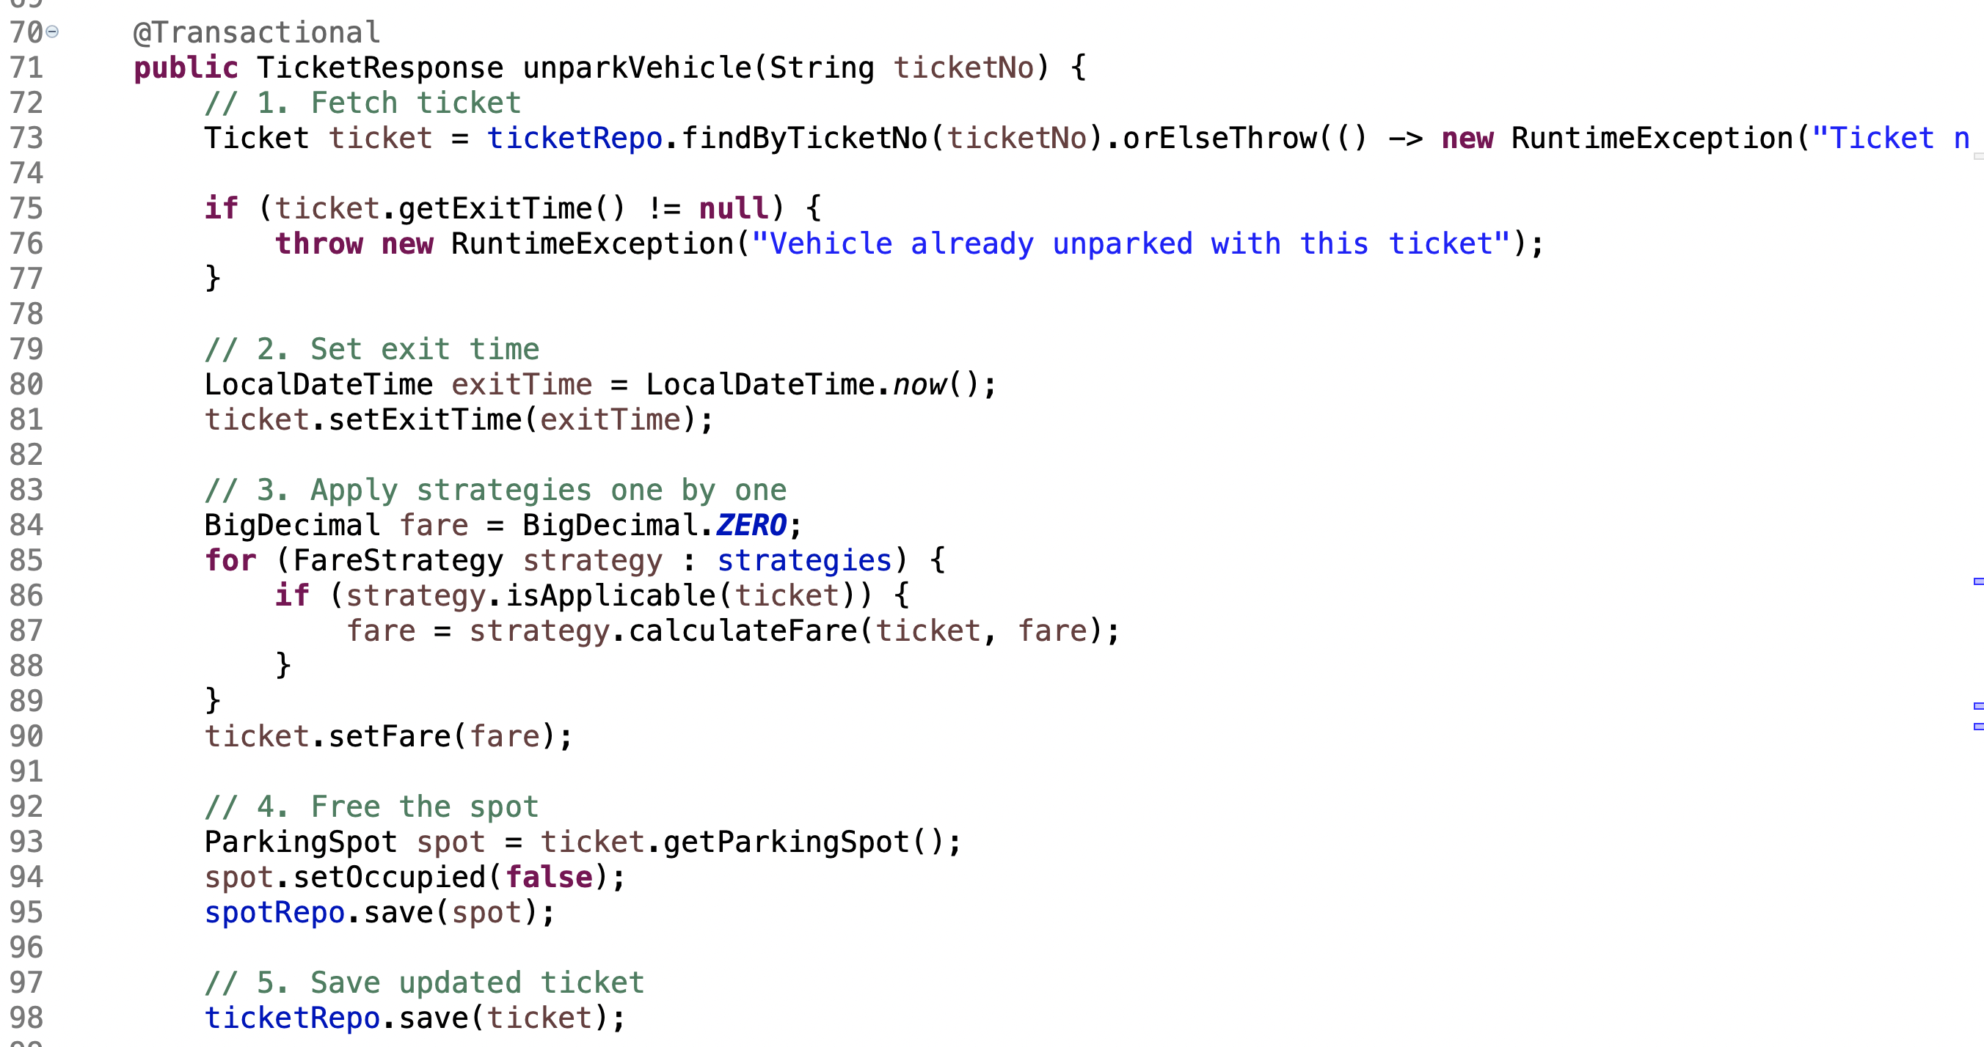
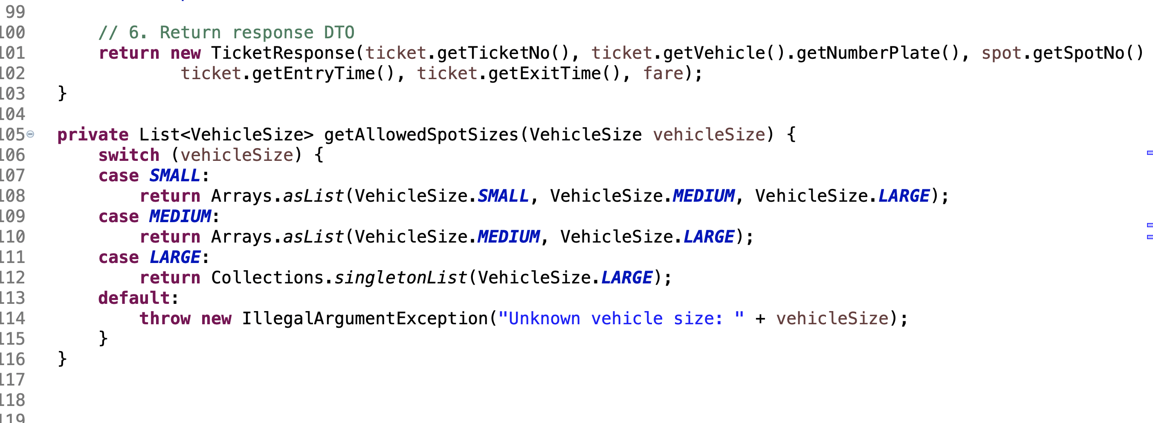
There are still many things we need to cover , I am writing few:
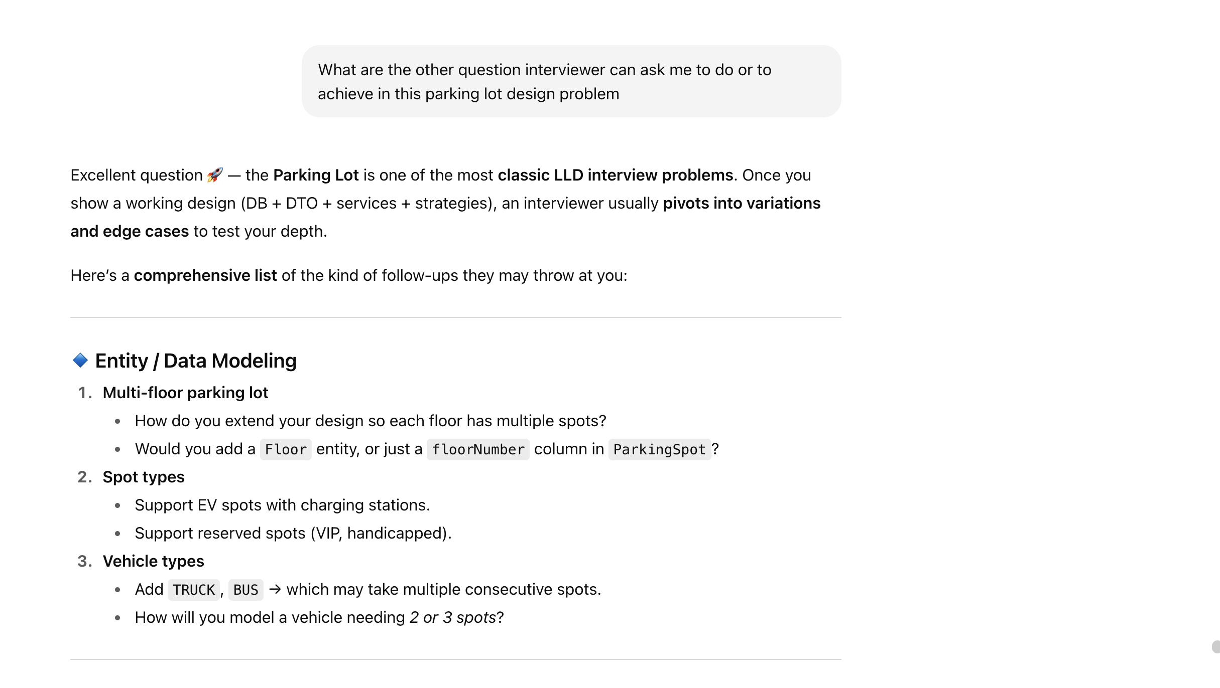
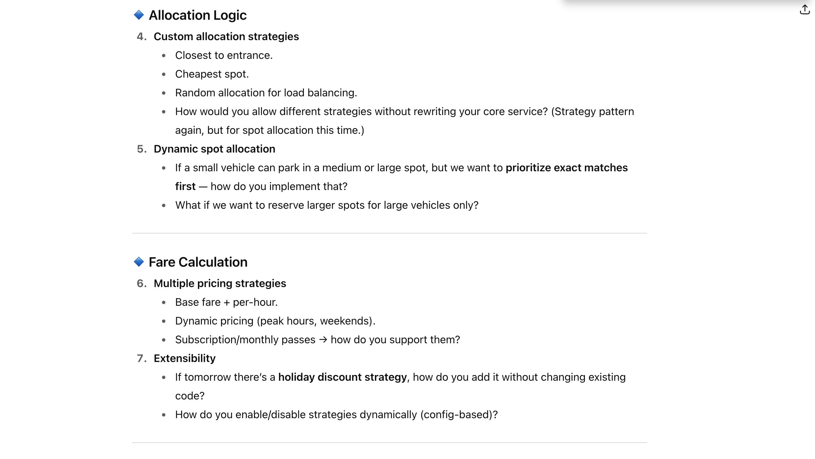
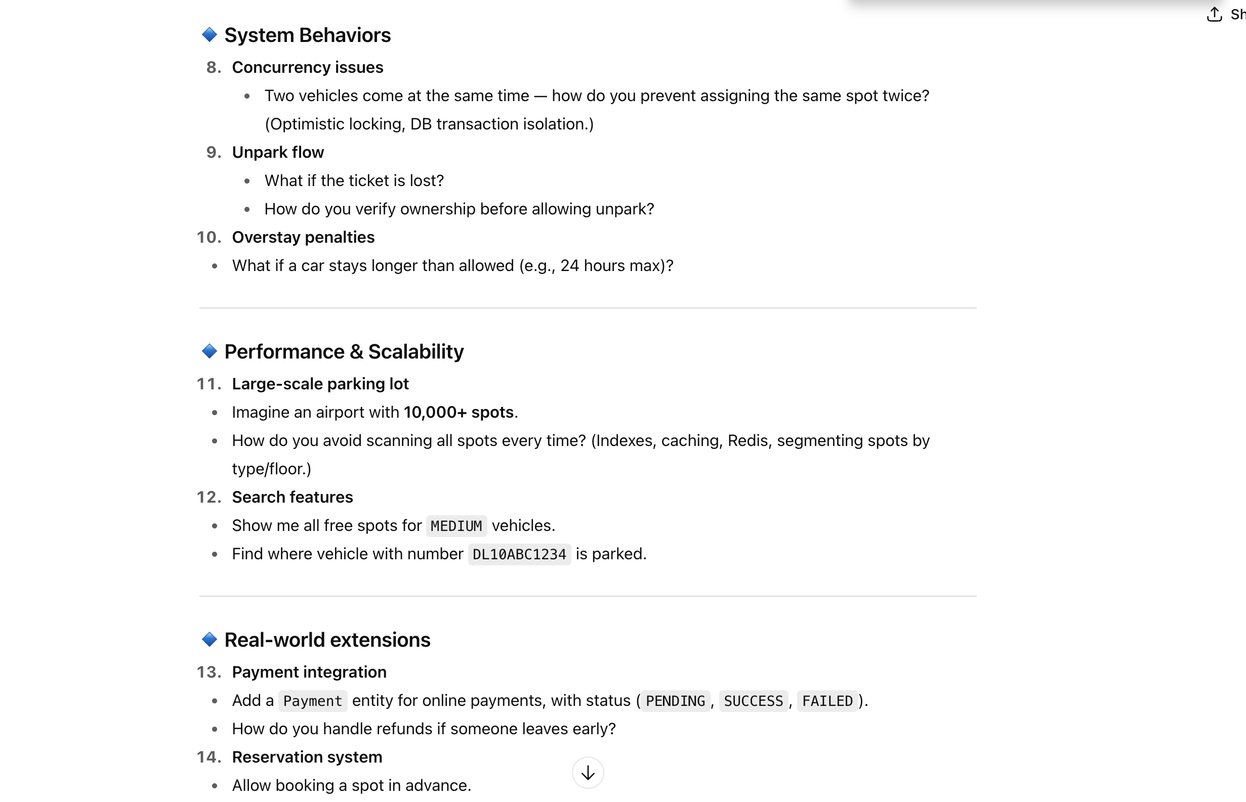
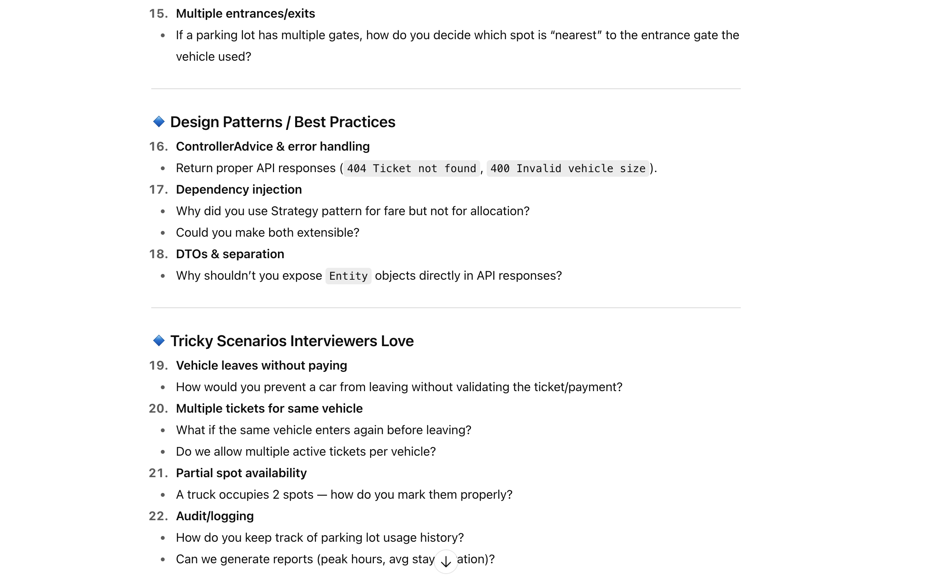

My goal here is to gather all the possible questions and extensions that anyone can ask me while I am solving this prob.

Multi-Floor Parking Lot
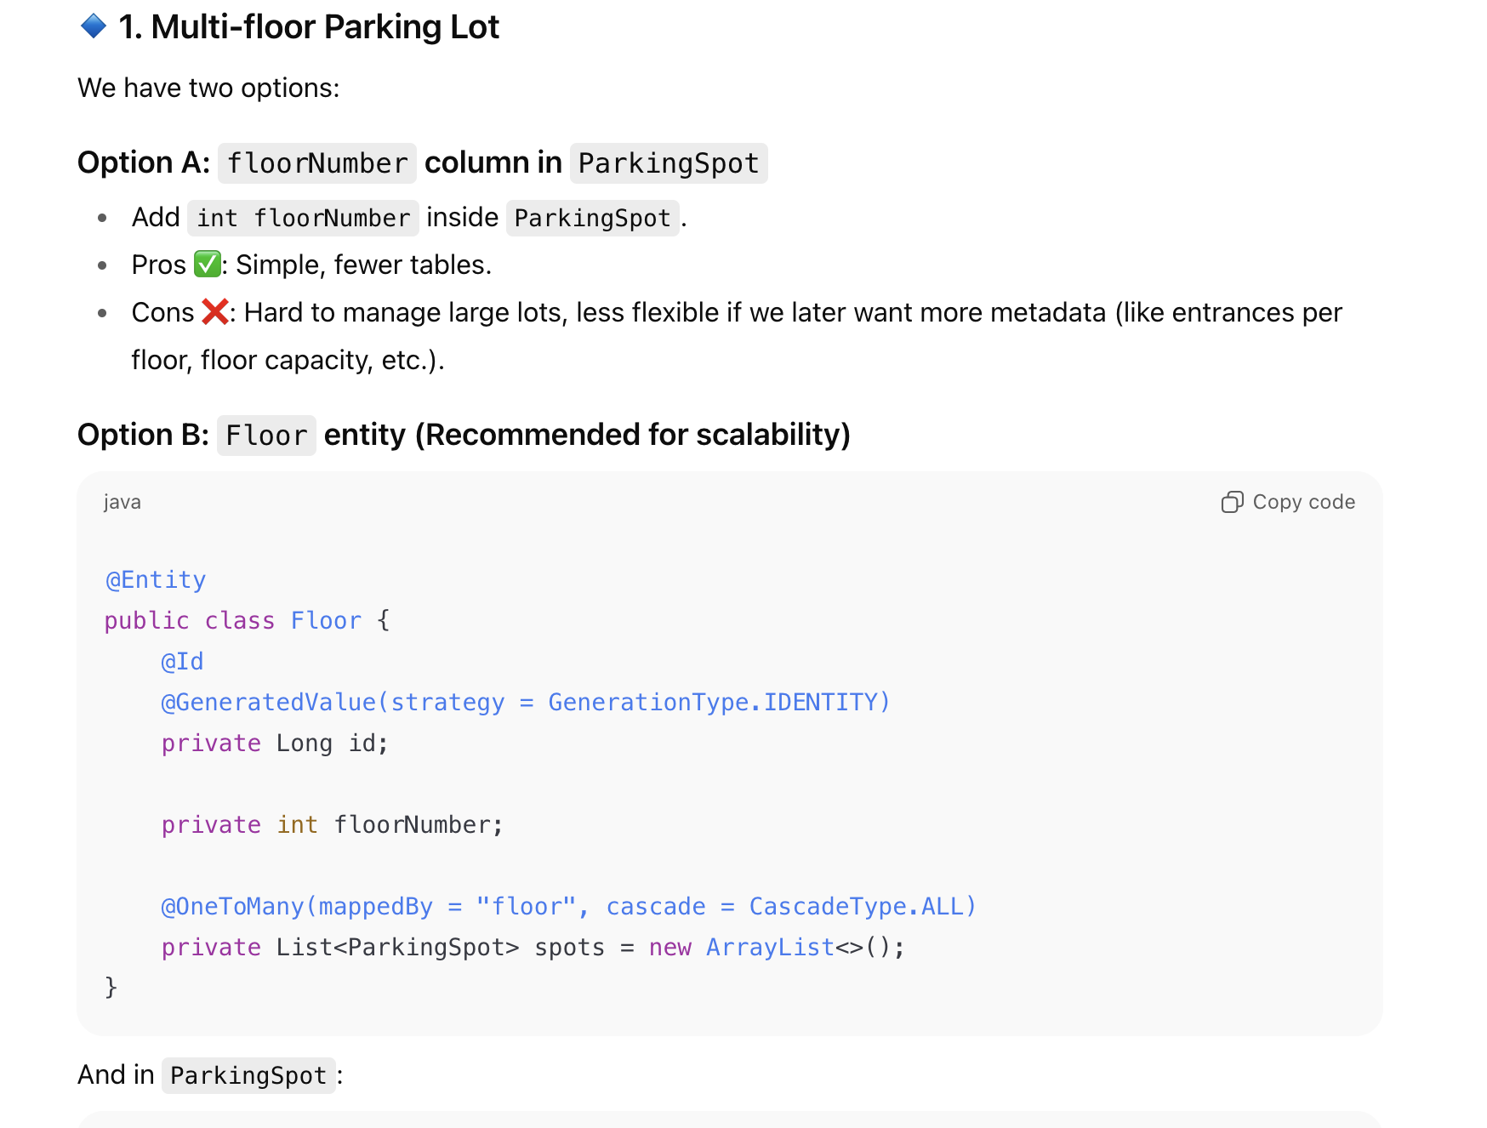
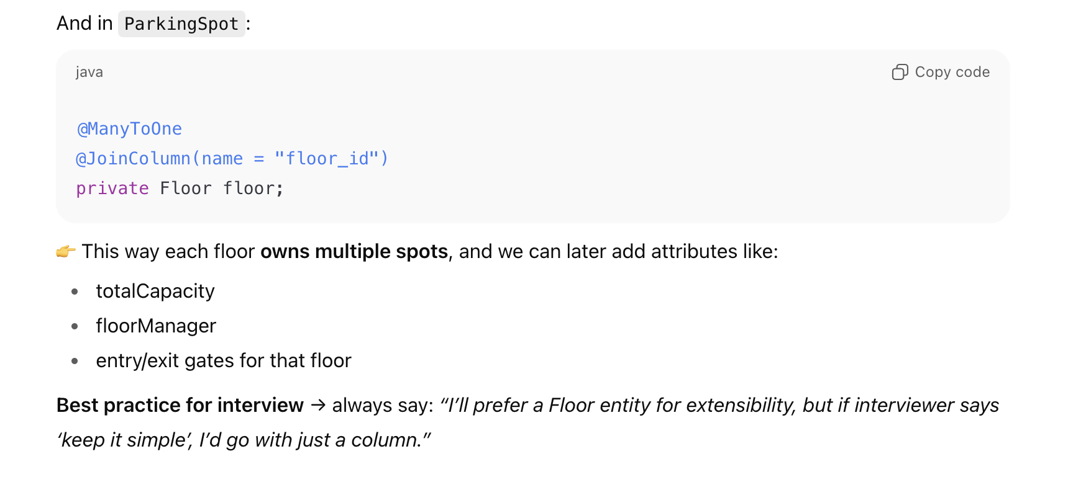
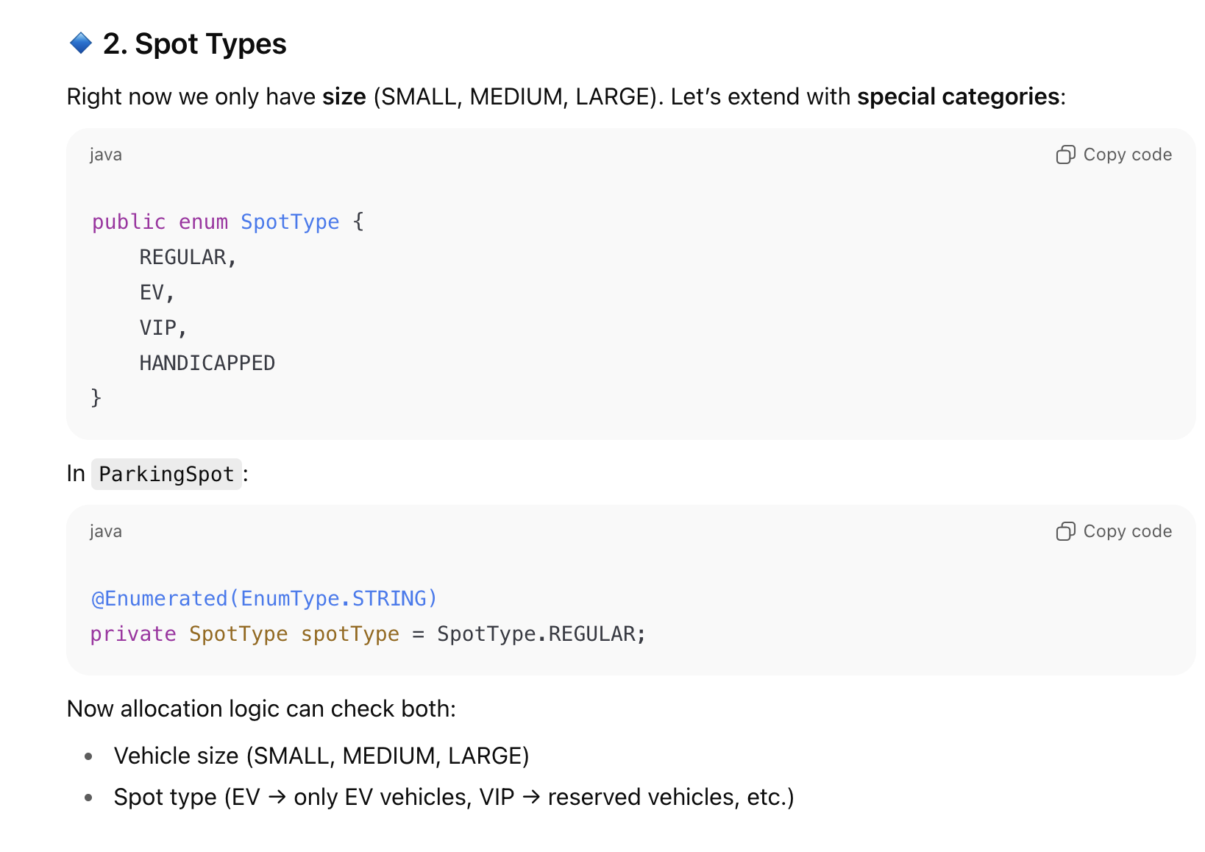
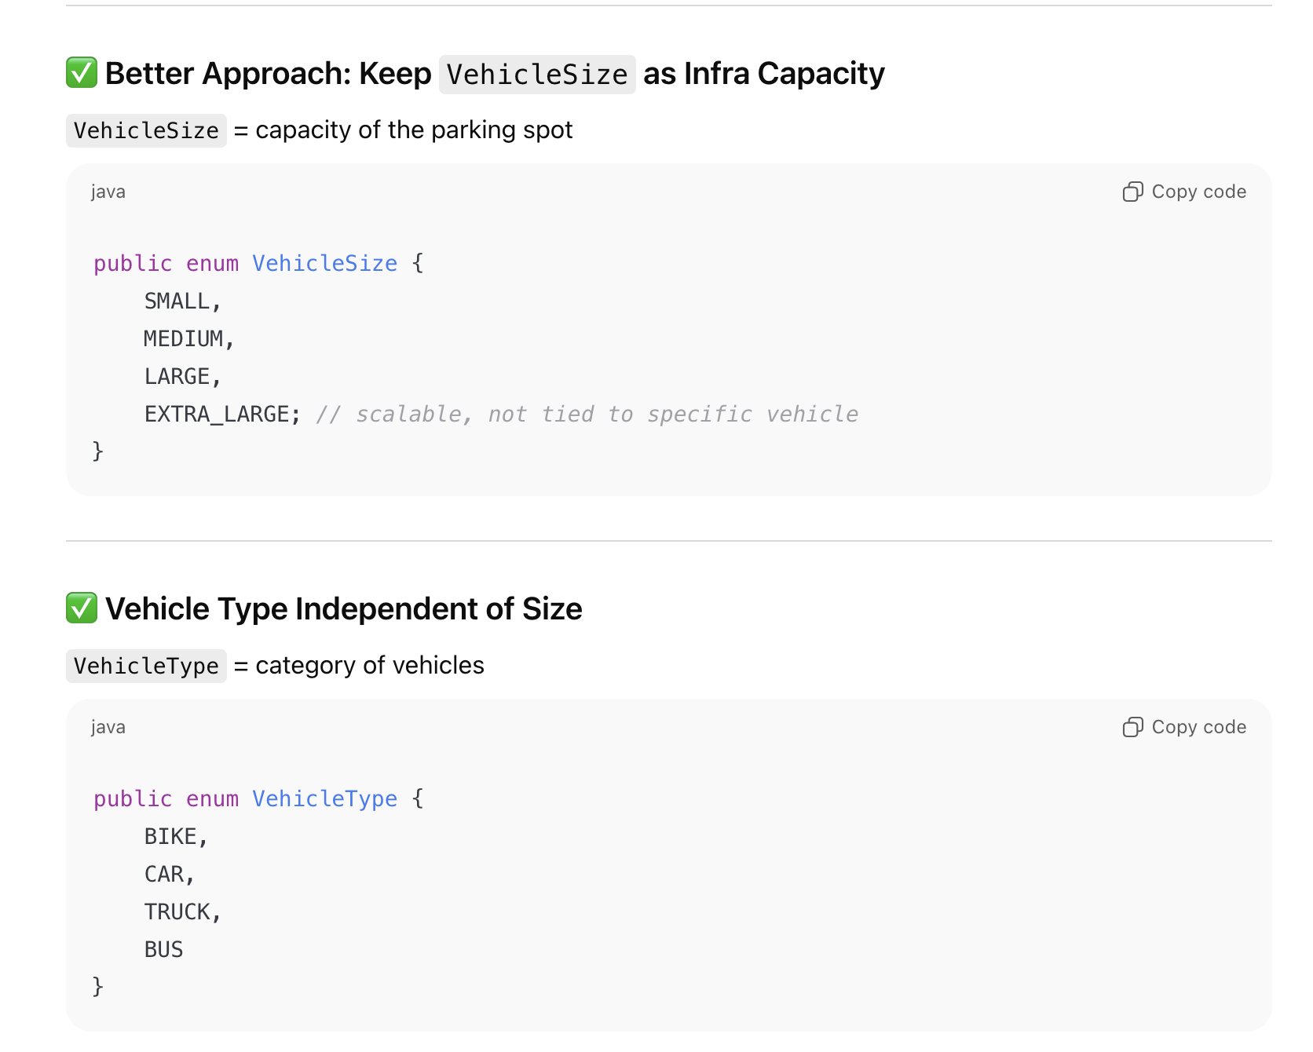

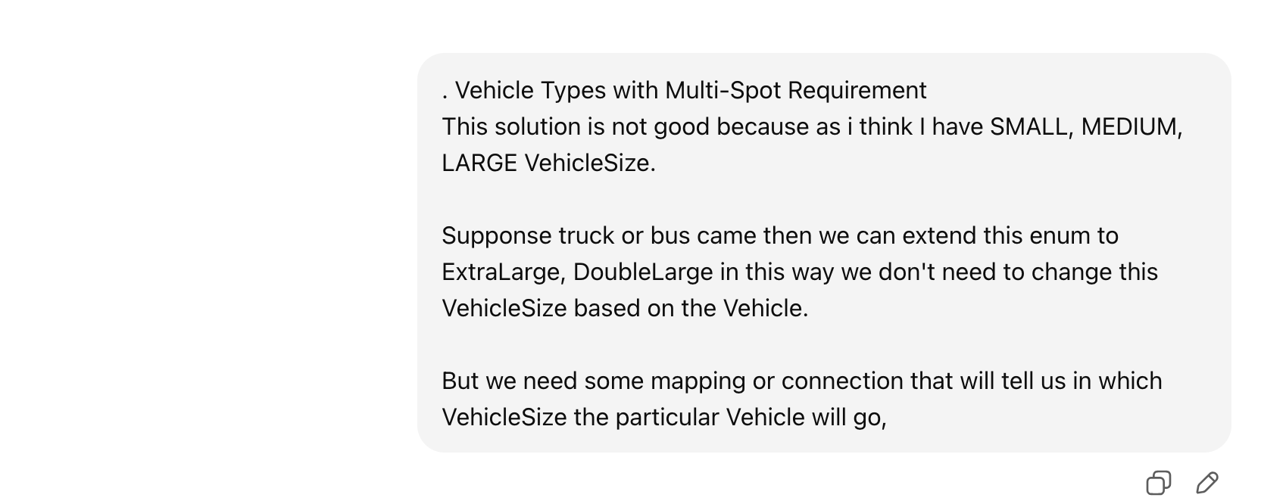
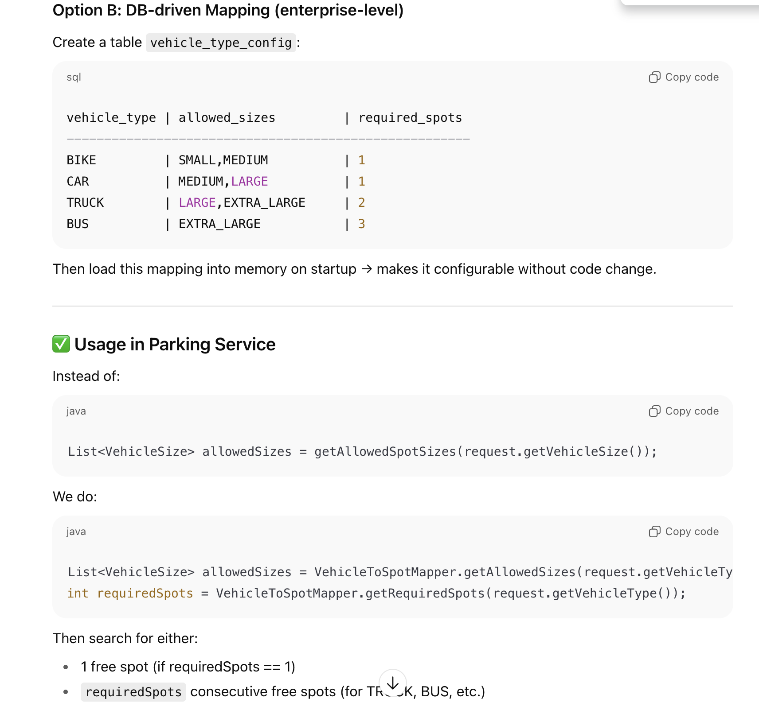
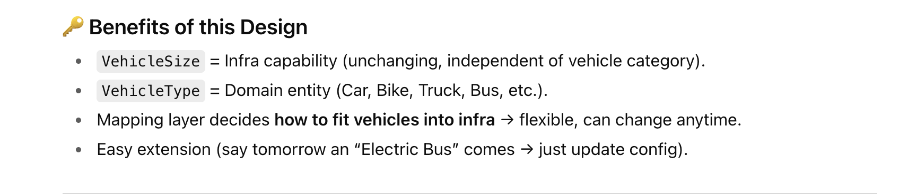

Approach 2: Vehicle Capacity Based Approach of Designing Parking Lot
(Complex but real time use)
This is little complex but imp to learn.
1) In this we have multi floor parking lot.
2) We don’t have fixed vehicle type, we support any type without changing code
3) In one spot if capacity is 5 then you can park 2 cars (of capacity 2) and one moto (of capacity 1)

UML diagram of Capacity based Parking Lot
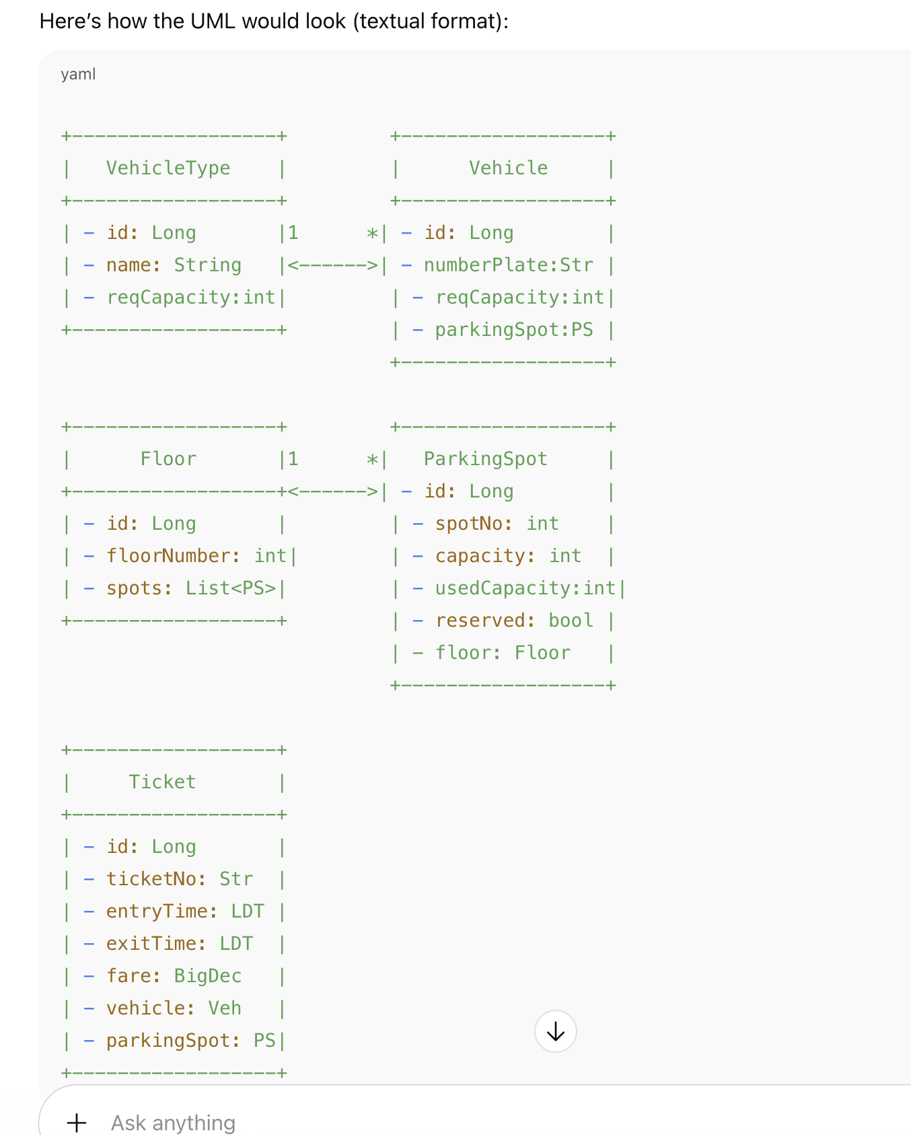
Refer Code to Understand this as it is little complex.

Two Vehicle at the same time handling (Locking Mechanism):
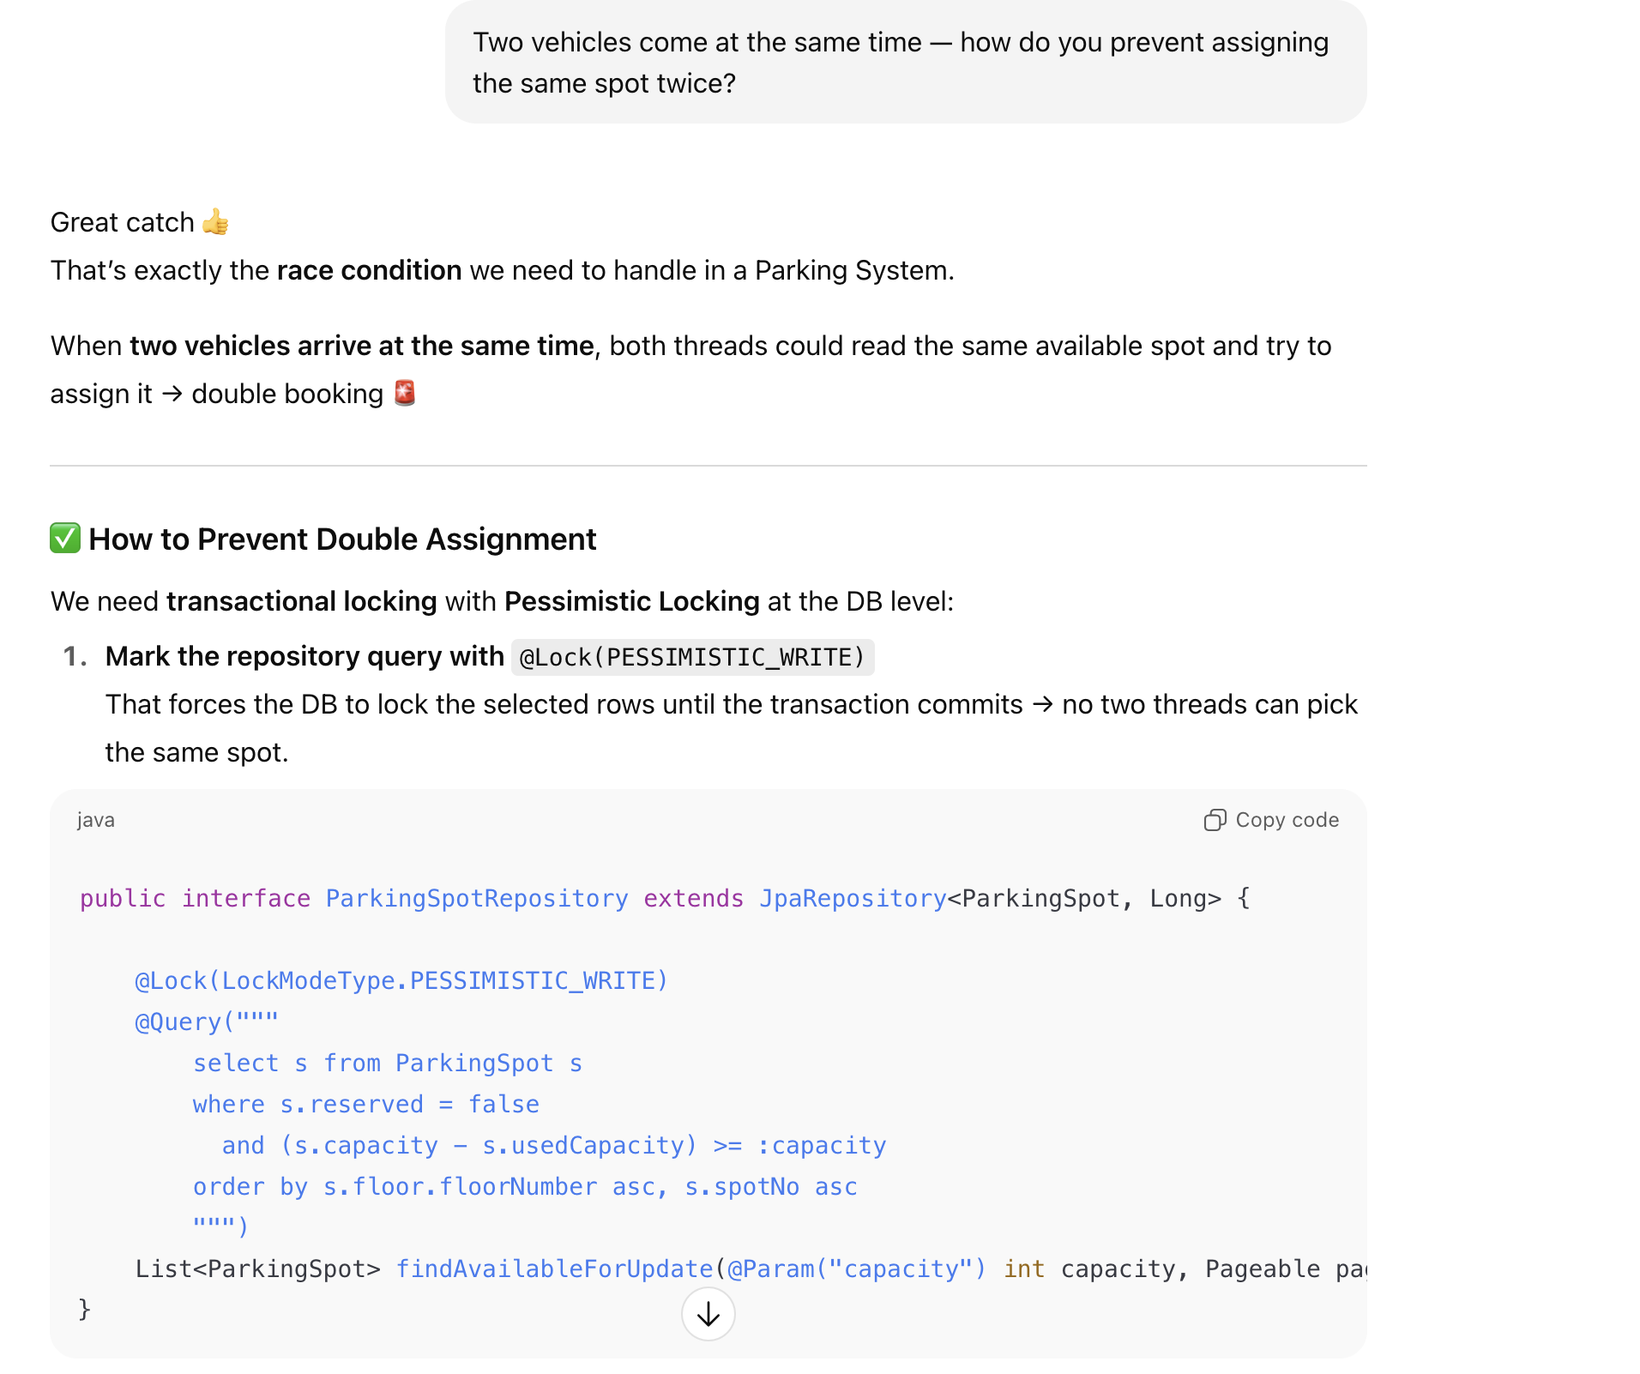
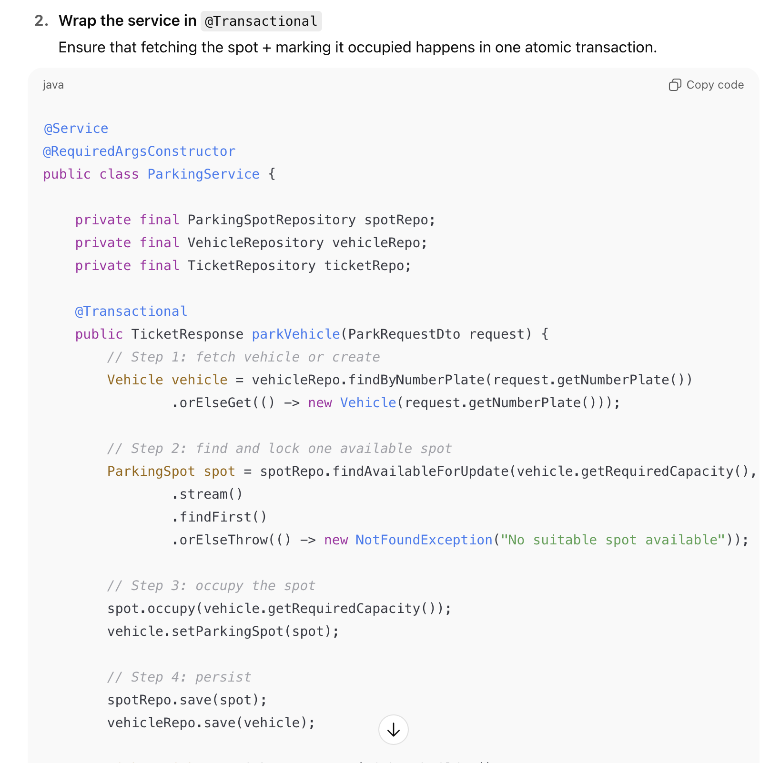
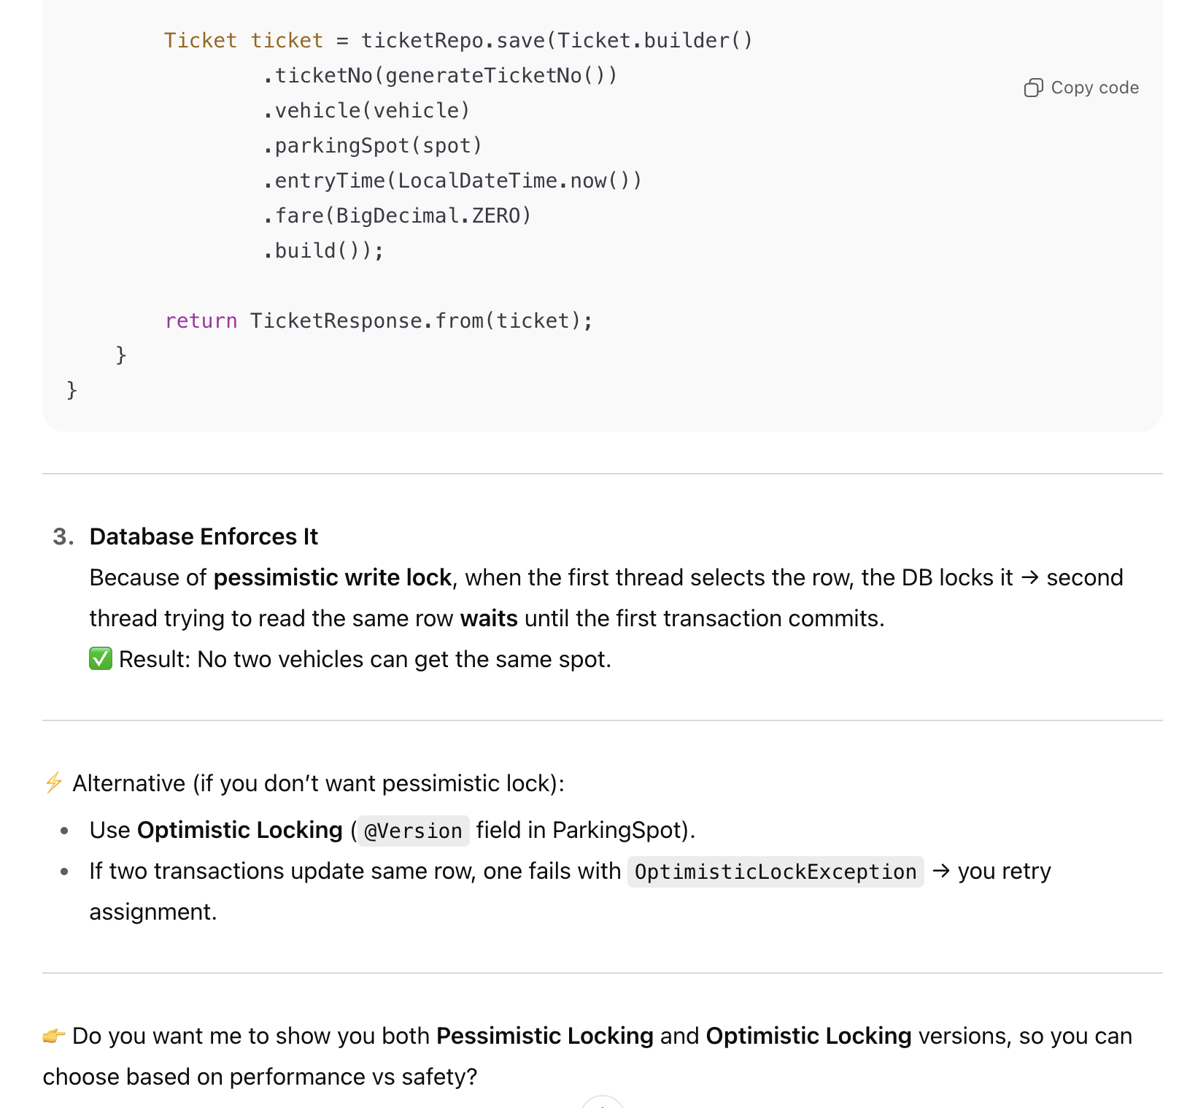

What is Pessimistic Locking
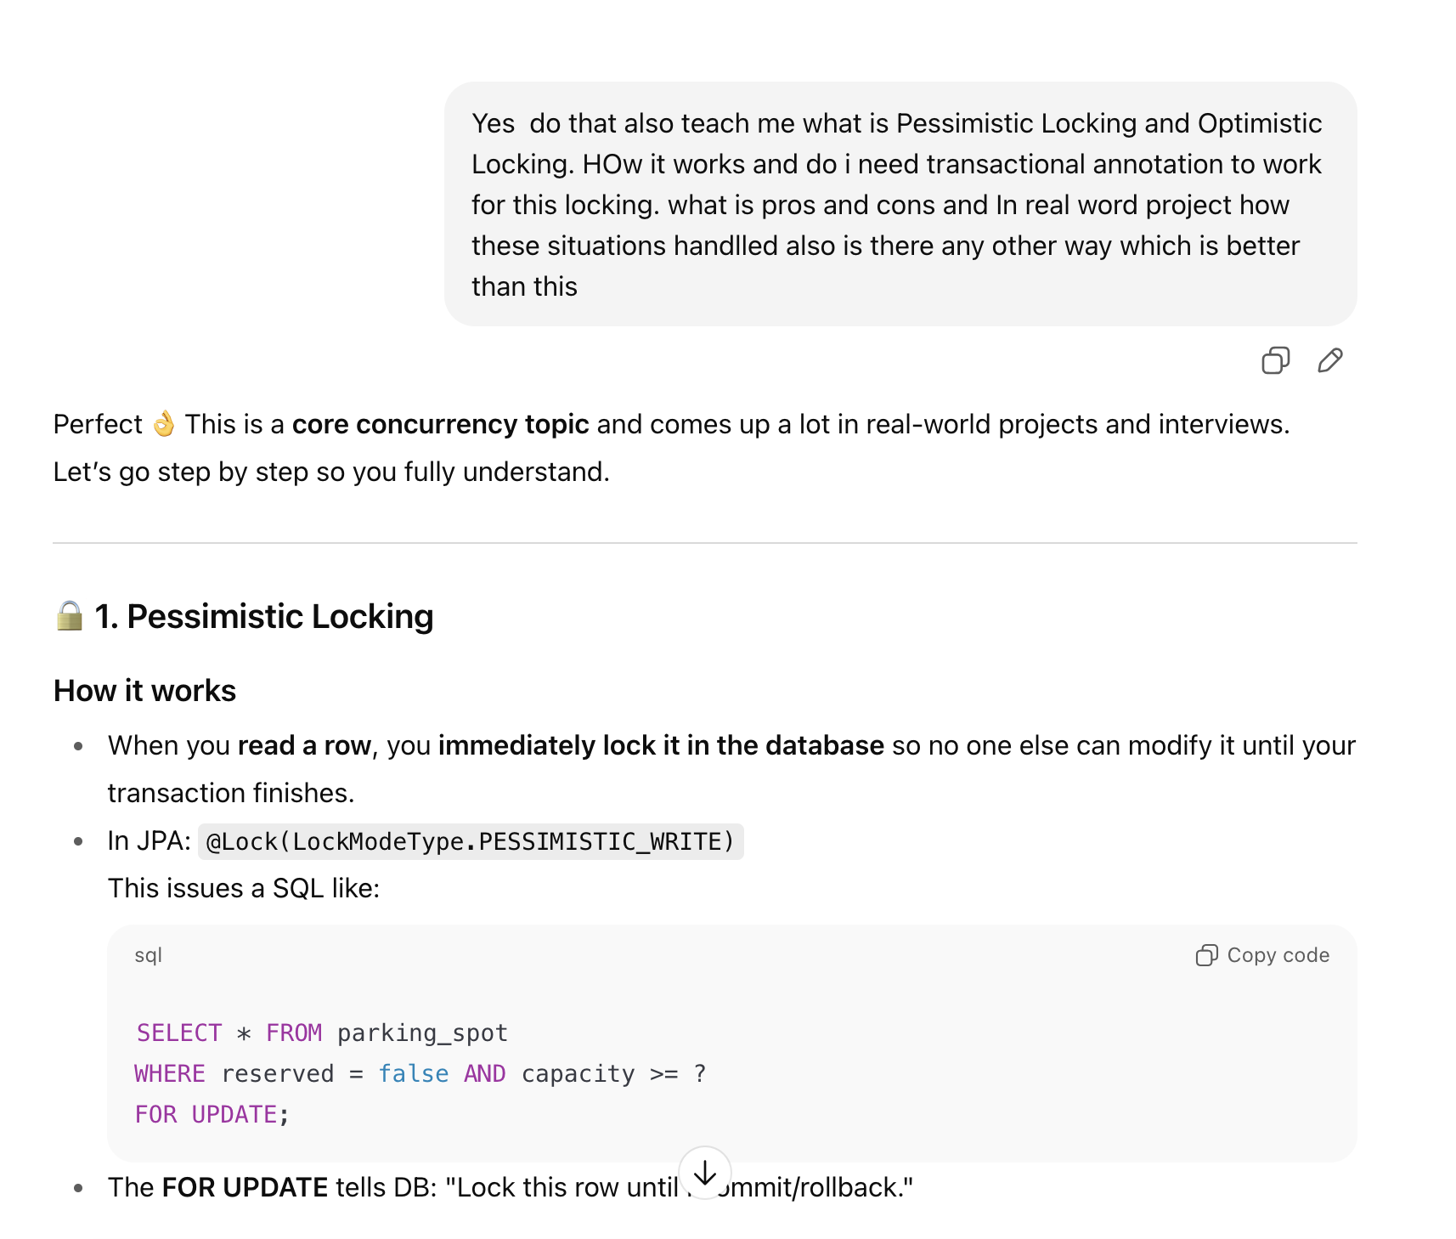

Optimistic Locking
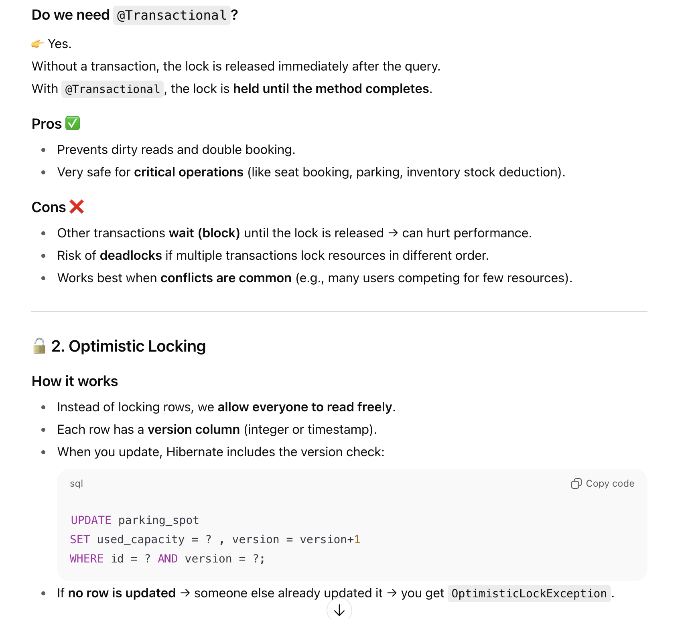
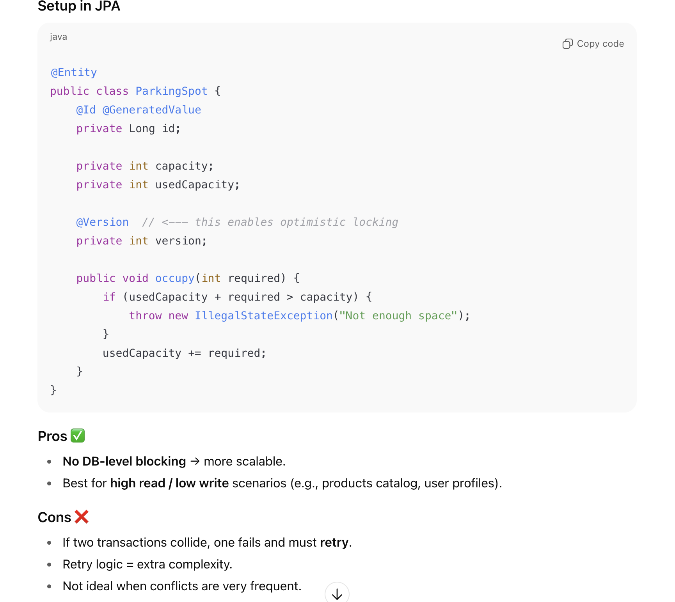

Optimistic v/s Pessimistic
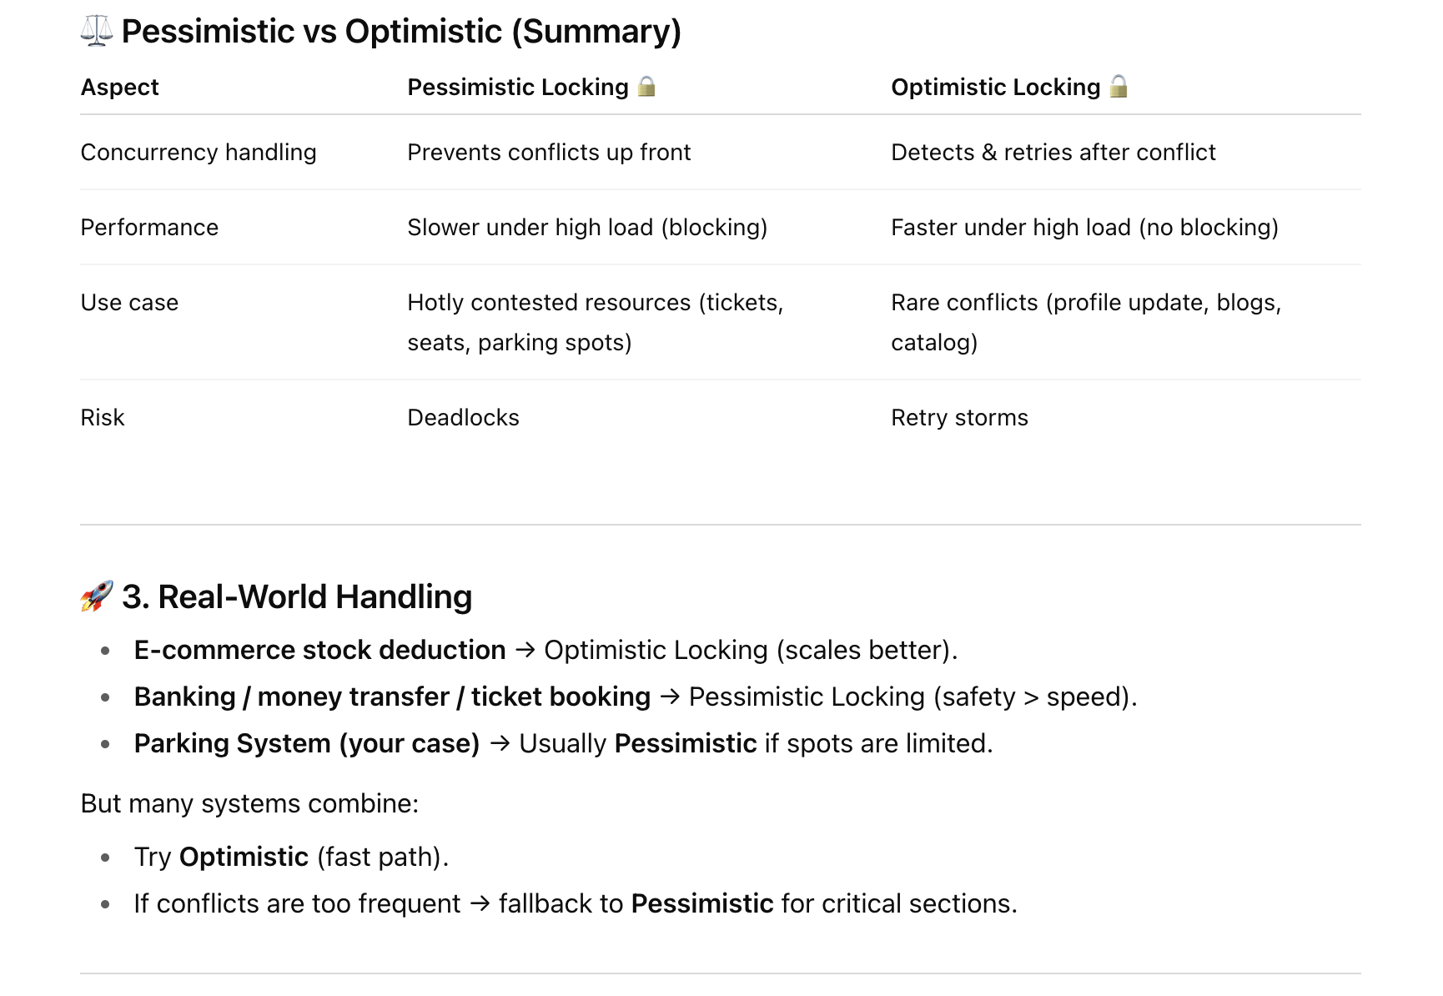
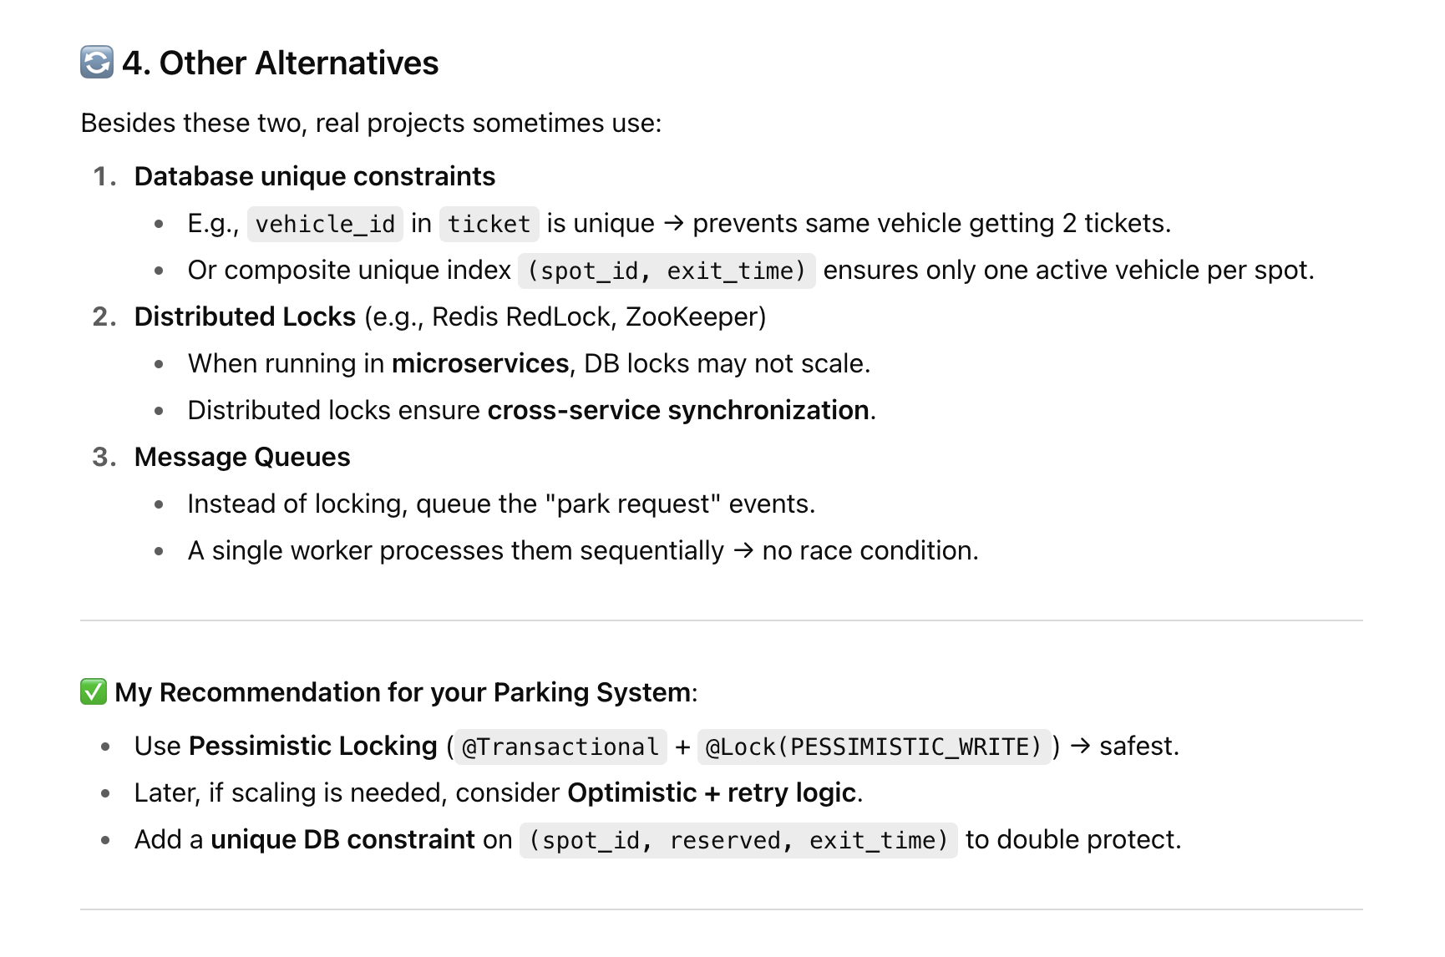

Optimistic Locking Code
We have already done in code with Pessimistic Locking version Now here I am using
Optimistic Locking version Just to see the change
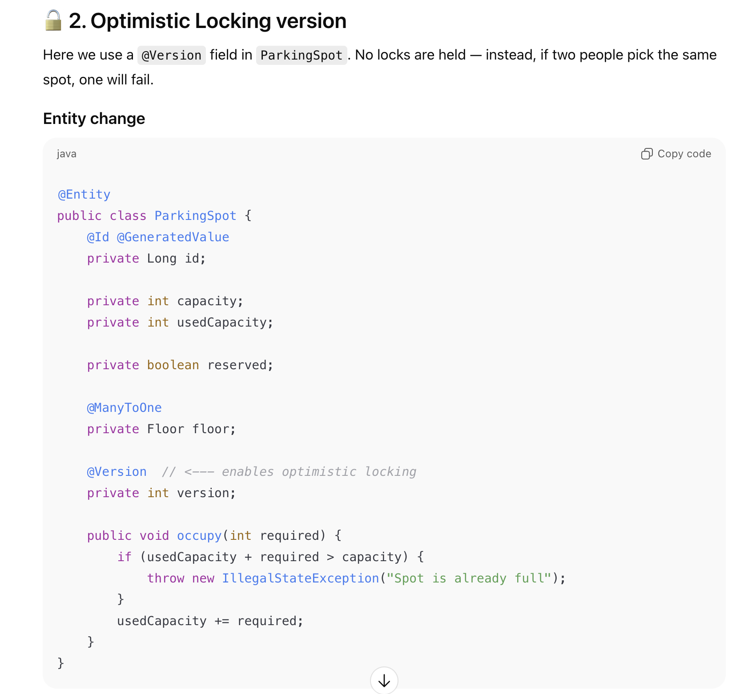
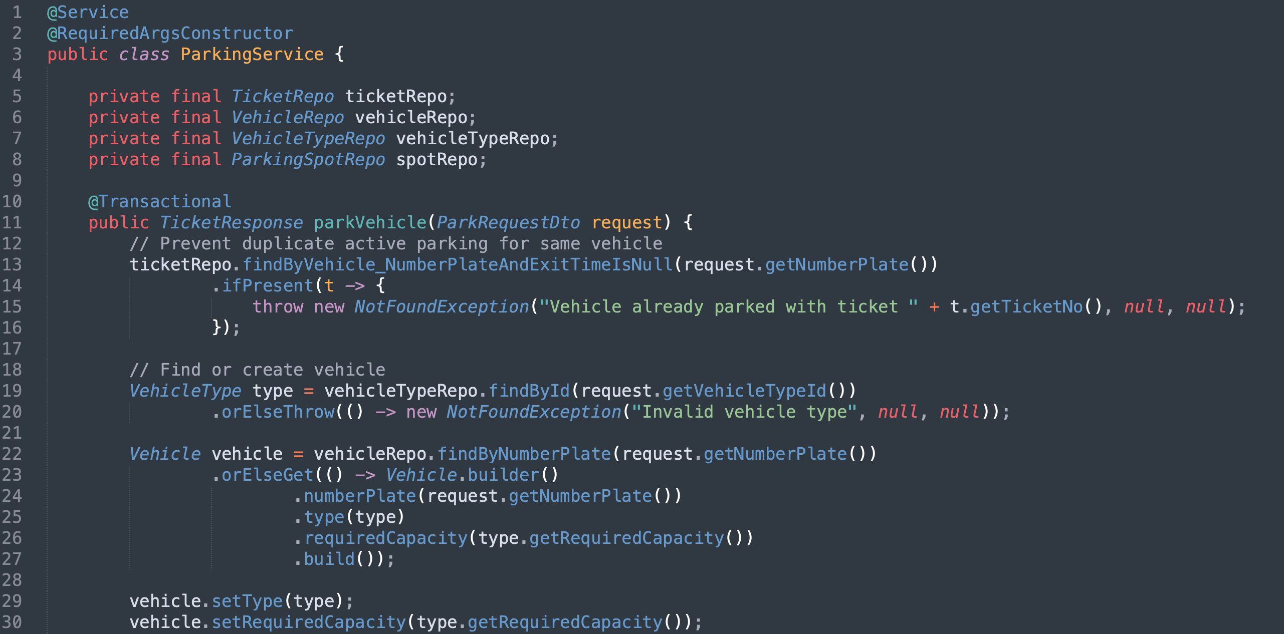

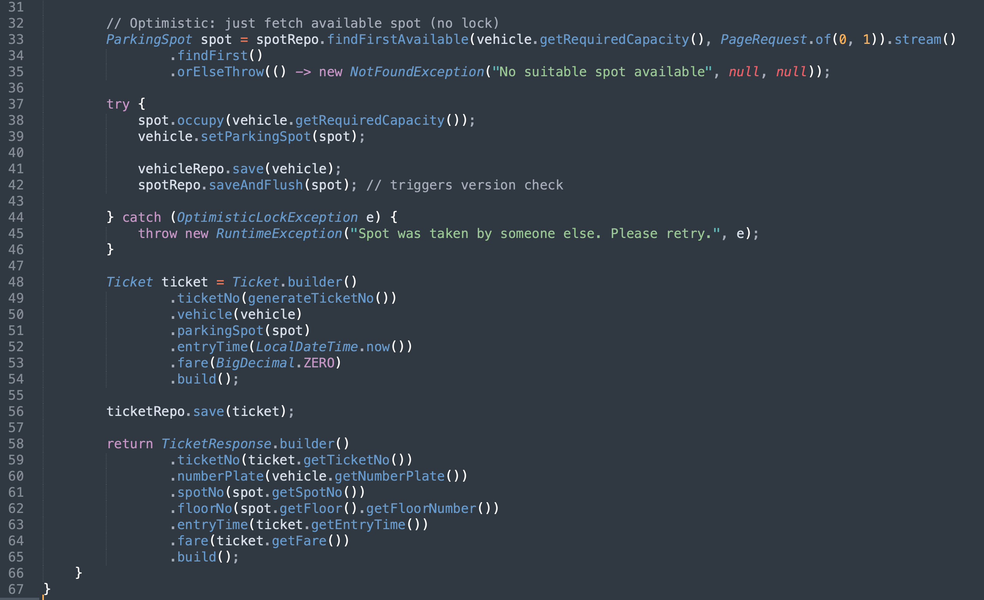
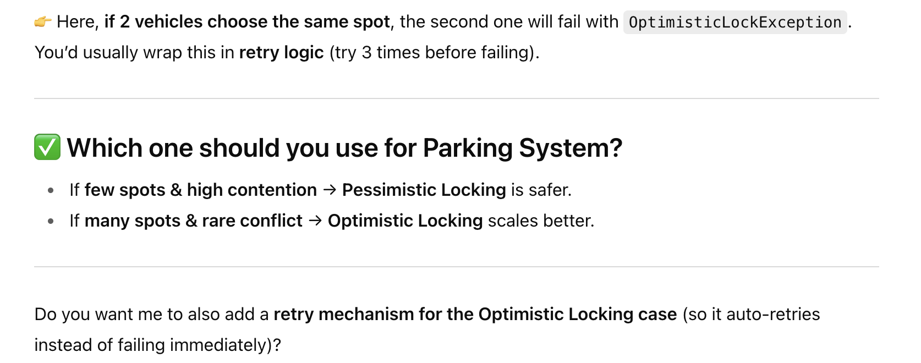

Retry Mechanism for Optimistic Locking
